**Lab Practical #01:**

Write a Prerequisite Programs in any language. (C/Java)

1. Calculate the swapping of two numbers using function.
2. Check if a number is prime.
3. Write a program with a function to calculate factorial.
4. Write a program to reverse a string using pointers.
5. Implement string functions like strlen, strcat, and strcmp.
6. Create a program to store and retrieve student details using struct.
7. Implement a program to read and write a text file.
8. Implement a program to check if a number is a power of 2 using bitwise operators.
9. Create a linked list or a dynamic array.
10. Write a program to encode a decimal into binary and vice versa.
11. Write a client-server chat application.
12. Implement file transfer over a network.
13. Calculate the swapping of two numbers using function.

#include <stdio.h>

void swapa(int a, int b)

{

    a = a + b;

    b = a - b;

    a = a - b;

    printf("After swapping: x = %d, y = %d\n", a, b);

}

void main()

{

    int x, y;

    printf("Enter two number: ");

    scanf("%d %d", &x, &y);

    printf("Before swapping: x = %d, y = %d\n", x, y);

    swapa(x, y);

}

## **Output:**

Enter two number: 5

6

Before swapping: x = 5, y = 6

After swapping: x = 6, y = 5

# **2** Check if a number is prime.

#include<stdio.h>

int main(){

int a,i;

int flag=0;

printf("Enter a number: ");

scanf("%d", &a);

for(i=2; i<=a/2; i++){

if(a % i == 0){

flag = 1;

break;

}

}

if(flag == 0)

printf("%d is a prime number.\n", a);

else

printf("%d is not a prime number.\n", a);

}

## Output:

Enter a number: 5

5 is a prime number.

# 3.Write a program with a function to calculate factorial.

#include <stdio.h>

int factorial(int n) {

    if (n == 0) {

        return 1;

    }

    return n * factorial(n - 1);

}

int main() {

    int n;

    printf("Enter a number: ");

    scanf("%d", &n);

    printf("Factorial of %d is %d\n", n, factorial(n));

    return 0;

}

# Output:

Enter a number: 5

Factorial of 5 is 120

# 4. Write a program to reverse a string using pointers.

#include <stdio.h>

#include <string.h>

void main(){

    char str[100];

    printf("Enter a string:");

    scanf("%s", str);

    int length=strlen(str);

    char *start = str;

    char *end = str + length - 1;

    while (start < end)

    {

        char temp = *start;

        *start = *end;

        *end = temp;

        start++;

        end--;

    }

    printf("The reverse of the string is \"%s\".\n", str);

}

# Output:

Enter a string:nirav

The reverse of the string is "varin".

# 5. Implement string functions like strlen, strcat, and strcmp.

#include <stdio.h>

#include <string.h>

int main() {

    const char *str = "Hello, World!";

    printf("Length of string: %zu\n", strlen(str));

    const char *str1 = "Hello";

    const char *str2 = "World";

    int cmp_result = strcmp(str1, str2);

    printf("Comparison result: %d\n", cmp_result);

    char dest[50] = "Hello, ";

    const char *src = "World!";

    strcat(dest, src);

    printf("Concatenated string: %s\n", dest);

    return 0;

}

# Output:

Length of string: 13

Comparison result: -1

Concatenated string: Hello, World!

# 6. Create a program to store and retrieve student details using struct.

#include <stdio.h>

#include <string.h>

struct Student {

    int id;

    char name[50];

    float grade;

};

void addStudent(struct Student *s, int id, const char *name, float grade) {

    s->id = id;

    strcpy(s->name, name);

    s->grade = grade;

}

void displayStudent(struct Student s) {

    printf("ID: %d\n", s.id);

    printf("Name: %s\n", s.name);

    printf("Grade: %.2f\n", s.grade);

}

int main() {

    struct Student student1;

    addStudent(&student1, 1, "nirav", 85.5);

    displayStudent(student1);

    return 0;

}

# Output:

ID: 1

Name: nirav

Grade: 85.50

# 7. Implement a program to read and write a text file.

#include <stdio.h>

int main() {

    const char *filename = "example.txt";

    FILE *file;

    char content[255];

    file = fopen(filename, "w");

    if (file == NULL) {

        printf("Error opening file!\n");

        return 1;

    }

    printf("Please enter content to write to the text file: ");

    fgets(content, sizeof(content), stdin);

    fprintf(file, "%s", content);

    fclose(file);

    printf("Content written to '%s'.\n", filename);

    file = fopen(filename, "r");

note:after run this code in this file directory create welcome.txt file and write in a file.

if (file == NULL) {

        printf("Error opening file!\n");

        return 1;

    }

    printf("File content:\n");

    while (fgets(content, sizeof(content), file) != NULL) {

        printf("%s", content);

    }

    fclose(file);

    return 0;

}

# Output:

Please enter content to write to the text file: hi welcome

Content written to 'example.txt'.

File content:

hi welcome

# 8.Implement a program to check if a number is a power of 2 using bitwise operators.

#include <stdio.h>

int isPowerOfTwo(int n) {

    return (n > 0) && ((n & (n - 1)) == 0);

}

int main() {

    int number;

    printf("Enter a number: ");

    scanf("%d", &number);

    if (isPowerOfTwo(number)) {

        printf("%d is a power of 2.\n", number);

    } else {

        printf("%d is not a power of 2.\n", number);

    }

    return 0;

}

# Output:

# 9. Create a linked list or a dynamic array.

Enter a number: 8

8 is a power of 2.

#include <stdio.h>

#include <stdlib.h>

// Define the structure for a linked list node

struct Node {

int data;

struct Node* next;

};

// Function to create a new node

struct Node* createNode(int data) {

struct Node* newNode = (struct Node*)malloc(sizeof(struct Node));

if (!newNode) {

printf("Memory allocation failed\n");

exit(1);

}

newNode->data = data;

newNode->next = NULL;

return newNode;

}

// Function to print the linked list

void printList(struct Node* head) {

struct Node* temp = head;

while (temp != NULL) {

printf("%d -> ", temp->data);

temp = temp->next;

}

printf("NULL\n");

}

// Main function

int main() {

struct Node* head = createNode(10);

head->next = createNode(20);

head->next->next = createNode(30);

printf("Linked List: ");

printList(head);

return 0;

}

# Output:

void printList(struct Node* head) {

    struct Node* temp = head;

    while (temp != NULL) {

        printf("%d -> ", temp->data);

        temp = temp->next;

    }

    printf("NULL\n");

}

int main() {

    struct Node* head = createNode(10);

    head->next = createNode(20);

    head->next->next = createNode(30);

    printf("Linked List: ");

    printList(head);

    return 0;

}

Linked List: 10 -> 20 -> 30 -> NULL

# 10. Write a program to encode a decimal into binary and vice versa.

#include <stdio.h>

#include <string.h>

void decimal_to_binary(int decimal) {

    int binary[32], i = 0;

    while (decimal > 0) {

        binary[i] = decimal % 2;

        decimal /= 2;

        i++;

    }

    printf("Binary representation: ");

    for (int j = i - 1; j >= 0; j--) {

        printf("%d", binary[j]);

    }

    printf("\n");

}

int binary_to_decimal(char binary[]) {

    int decimal = 0, base = 1, len = strlen(binary);

    for (int i = len - 1; i >= 0; i--) {

        if (binary[i] == '1') {

            decimal += base;

   }

        base *= 2;

    }

    return decimal;

}

int main() {

    int choice;

    printf("Choose: 1. Decimal to Binary 2. Binary to Decimal: ");

    scanf("%d", &choice);

    if (choice == 1) {

        int decimal;

        printf("Enter decimal number: ");

        scanf("%d", &decimal);

        decimal_to_binary(decimal);

    } else if (choice == 2) {

        char binary[32];

        printf("Enter binary number: ");

        scanf("%s", binary);

        printf("Decimal representation: %d\n", binary_to_decimal(binary));

    } else {

        printf("Invalid option.\n");

    }

    return 0;

}

# Output:

Choose: 1. Decimal to Binary 2. Binary to Decimal: 2

Enter binary number: 1100110

Decimal representation: 102

# 11. Write a client-server chat application.(JAVA)

**SERVER**

import java.io.*;

import java.net.*;

public class ChatServer {

    public static void main(String[] args) {

        try (ServerSocket serverSocket = new ServerSocket(12345)) {

            System.out.println("Server is running and waiting for a client...");

            Socket clientSocket = serverSocket.accept();

            System.out.println("Client connected!");

            BufferedReader input = new BufferedReader(new InputStreamReader(clientSocket.getInputStream()));

            PrintWriter output = new PrintWriter(clientSocket.getOutputStream(), true);

            Thread readerThread = new Thread(() -> {

                try {

                    String clientMessage;

                    while ((clientMessage = input.readLine()) != null) {

                        System.out.println("Client: " + clientMessage);

                    }

                } catch (IOException e) {

                    System.out.println("Connection closed.");

                }

            });

  });

            readerThread.start();

            BufferedReader consoleInput = new BufferedReader(new InputStreamReader(System.in));

            String serverMessage;

            while ((serverMessage = consoleInput.readLine()) != null) {

                output.println(serverMessage);

            }

        } catch (IOException e) {

            System.out.println("Server error: " + e.getMessage());

        }

    }

}

**CLIENT**

import java.io.*;

import java.net.*;

public class ChatClient {

    public static void main(String[] args) {

        try (Socket socket = new Socket("localhost", 12345)) {

            System.out.println("Connected to the server!")

  BufferedReader input = new BufferedReader(new InputStreamReader(socket.getInputStream()));

            PrintWriter output = new PrintWriter(socket.getOutputStream(), true);

            Thread readerThread = new Thread(() -> {

                try {

                    String serverMessage;

                    while ((serverMessage = input.readLine()) != null) {

                        System.out.println("Server: " + serverMessage);

                    }

                } catch (IOException e) {

                    System.out.println("Connection closed.");

                }

            });

            readerThread.start();

            BufferedReader consoleInput = new BufferedReader(new InputStreamReader(System.in));

            String clientMessage;

            while ((clientMessage = consoleInput.readLine()) != null) {

                output.println(clientMessage);

            }

        } catch (IOException e) {

            System.out.println("Client error: " + e.getMessage());

        }

    }

}

# Output:

**Server**

F:\semester 6\Information Network Security(INS)\lab\lab 1\chat>javac ChatServer.java ChatClient.java

F:\semester 6\Information Network Security(INS)\lab\lab 1\chat>java ChatServer

Server is running and waiting for a client...

Client connected!

hi

Client: hello

good morning

Client: how are you

i am fine

**Client**

F:\semester 6\Information Network Security(INS)\lab\lab 1\chat>java ChatClient

Connected to the server!

Server: hi

hello

Server: good morning

how are you

Server: i am fine

# 13.Implement file transfer over a network.

**SERVER**

import java.io.*;

import java.net.*;

public class FileTransferServer {

    public static void main(String[] args) {

        final int PORT = 12345;

        try (ServerSocket serverSocket = new ServerSocket(PORT)) {

            System.out.println("Server is running and waiting for a connection...");

            Socket clientSocket = serverSocket.accept();

            System.out.println("Client connected!");

            // File to send

            File fileToSend = new File("file-to-send.txt");

            if (!fileToSend.exists()) {

                System.out.println("File does not exist.");

                return;

            }

            // Sending file

            try (BufferedInputStream fileInput = new BufferedInputStream(new FileInputStream(fileToSend));

                 OutputStream outputStream = clientSocket.getOutputStream()) {

                System.out.println("Sending file: " + fileToSend.getName());

 byte[] buffer = new byte[4096];

                int bytesRead;

                while ((bytesRead = fileInput.read(buffer)) > 0) {

                    outputStream.write(buffer, 0, bytesRead);

                }

                System.out.println("File sent successfully!");

            }

        } catch (IOException e) {

            System.out.println("Server error: " + e.getMessage());

        }

    }

}

**CLIENT**

import java.io.*;

import java.net.*;

public class FileTransferClient {

    public static void main(String[] args) {

        final String SERVER_ADDRESS = "localhost";

        final int PORT = 12345;

        try (Socket socket = new Socket(SERVER_ADDRESS, PORT)) {

            System.out.println("Connected to the server!");

            File receivedFile = new File("received-file.txt");

            try (InputStream inputStream = socket.getInputStream();

                 BufferedOutputStream fileOutput = new BufferedOutputStream(new FileOutputStream(receivedFile))) {

                System.out.println("Receiving file...");

                byte[] buffer = new byte[4096];

                int bytesRead;

                while ((bytesRead = inputStream.read(buffer)) > 0) {

                    fileOutput.write(buffer, 0, bytesRead);

                }

                System.out.println("File received successfully: " + receivedFile.getAbsolutePath());

            }

        } catch (IOException e) {

            System.out.println("Client error: " + e.getMessage());

        }

    }

}

# Output:

**SERVER**

F:\semester 6\Information Network Security(INS)\lab\lab 1\file>java FileTransferServer

Server is running and waiting for a connection...

Client connected!

Sending file: file-to-send.txt

File sent successfully!

**CLIENT**

F:\semester 6\Information Network Security(INS)\lab\lab 1\file>java FileTransferClient

Connected to the server!

Receiving file...

File received successfully: F:\semester 6\Information Network Security(INS)\lab\lab 1\file\received-file.txt

**Difference Between Active Attack and Passive Attack**

|  |  |
| --- | --- |
| **Active Attack** | **Passive Attack** |
| In an active attack, Modification in information takes place. | While in a passive attack, Modification in the information does not take place. |
| Active Attack is a danger to **Integrity** as well as **availability**. | Passive Attack is a danger to **Confidentiality**. |
| In an active attack, attention is on prevention. | While in passive attack attention is on detection. |
| Due to active attacks, the execution system is always damaged. | While due to passive attack, there is no harm to the system. |
| In an active attack, Victim gets informed about the attack. | While in a passive attack, Victim does not get informed about the attack. |
| In an active attack, System resources can be changed. | While in passive attack, System resources are not changing. |
| Active attack influences the services of the system. | While in a passive attack, information and messages in the system or network are acquired. |
| In an active attack, information collected through passive attacks is used during execution. | While passive attacks are performed by collecting information such as passwords, and messages by themselves. |
| An active attack is tough to restrict from entering systems or networks. | Passive Attack is easy to prohibit in comparison to active attack. |
| Can be easily detected. | Very difficult to detect. |
| The purpose of an active attack is to harm the ecosystem. | The purpose of a passive attack is to learn about the ecosystem. |
| In an active attack, the original information is modified. | In passive attack original information is Unaffected. |
| The duration of an active attack is short. | The duration of a passive attack is long. |
| The prevention possibility of active attack is High | The prevention possibility of passive attack is low. |
| Complexity is High | Complexity is low. |

**Lab Practical #02:**

**Implement plain text to cipher text using operation of AND or XOR**

# XOR Code:

#include <stdio.h>

#include <string.h>

void xorEncryptDecrypt(const char text[], char output[], char key) {

for (int i = 0; i < strlen(text); i++) {

output[i] = text[i] ^ key;

}

output[strlen(text)] = '\0';

}

void printBinary(const char text[]) {

for (int i = 0; i < strlen(text); i++) {

for (int j = 7; j >= 0; j--) {

printf("%d", (text[i] >> j) & 1);

}

printf(" ");

}

printf("\n");

}

int main() {

char text[100], encrypted[100], decrypted[100];

char key;

printf("Enter text: ");

fgets(text, sizeof(text), stdin);

text[strcspn(text, "\n")] = '\0';

printf("Enter key (single character): ");

scanf(" %c", &key);

xorEncryptDecrypt(text, encrypted, key);

printf("Encrypted text : %d \n", encrypted);

printf("Encrypted text (as binary): ");

printBinary(encrypted);

xorEncryptDecrypt(encrypted, decrypted, key);

printf("Decrypted text: %s\n", decrypted);

return 0;

}

## Output:

Enter text: hello

Enter key (single character): k

Encrypted text : 6421975

Encrypted text (as binary): 00000011 00001110 00000111 00000111 00000100

Decrypted text: hello

# 2 AND Code:

#include <stdio.h>

#include <string.h>

void andEncrypt(const char text[], char output[], char key) {

for (int i = 0; i < strlen(text); i++) {

output[i] = text[i] & key;

}

output[strlen(text)] = '\0';

}

void printBinary(const char text[]) {

for (int i = 0; i < strlen(text); i++) {

for (int j = 7; j >= 0; j--) {

printf("%d", (text[i] >> j) & 1);

}

printf(" ");

}

printf("\n");

}

int main() {

char text[100], encrypted[100], decrypted[100];

char key;

printf("Enter text: ");

fgets(text, sizeof(text), stdin);

text[strcspn(text, "\n")] = '\0';

printf("Enter key (single character): ");

scanf(" %c", &key);

andEncrypt(text, encrypted, key);

printf("Encrypted text (as binary): ");

printBinary(encrypted);

return 0;

}

# Output:

Enter text: hello

Enter key (single character): k

Encrypted text (as binary): 01101000 01100001 01101000 01101000 01101011

**Lab Practical #03:**

**Implementation of Caesar Cipher Techniques.**

#include <stdio.h>

#include <string.h>

void enc(char *str, int key) {

int i;

char str2[30];

for (i = 0; i < strlen(str); i++) {

if (str[i] >= 'a' && str[i] <= 'z') {

str2[i] = ((str[i] - 'a' + key) % 26) + 'a';

} else if (str[i] >= 'A' && str[i] <= 'Z') {

str2[i] = ((str[i] - 'A' + key) % 26) + 'A';

} else {

str2[i] = str[i];

}

}

str2[i] = '\0';

strcpy(str, str2);

}

int main() {

char str[30];

int key;

printf("Enter String for Encryption: ");

fgets(str, sizeof(str), stdin);

str[strcspn(str, "\n")] = 0;

printf("Enter Key in integer: ");

scanf("%d", &key);

enc(str, key);

printf("Encrypted String: %s\n", str);

return 0;

}

# Output:

Enter String for Encryption: welcome

Enter Key in integer: 4

Encrypted String: aipgsqi

printf("Enter String for Encryption: ");

fgets(str, sizeof(str), stdin);

str[strcspn(str, "\n")] = 0;

printf("Enter Key in integer: ");

scanf("%d", &key);

enc(str, key);

printf("Encrypted String: %s\n", str);

return 0;

}

**Lab Practical #04:**

**Implementation of monoalphabetic and polyalphabetic substitution cipher technique.**

# Monoalphabetic cipher:

#include <stdio.h>

#include <string.h>

#include <ctype.h>

void generateKey(char *inputKey, char *key) {

int len = strlen(inputKey);

int used[26] = {0};

int index = 0;

for (int i = 0; i < len; i++) {

if (isalpha(inputKey[i])) {

char c = toupper(inputKey[i]);

if (!used[c - 'A']) {

used[c - 'A'] = 1;

key[index++] = c;

}

} }

for (int i = 0; i < 26; i++) {

if (!used[i]) {

key[index++] = 'A' + i;

}

}

key[26] = '\0'

}

void encrypt(char *plaintext, char *substitution) {

int len = strlen(plaintext);

for (int i = 0; i < len; i++) {

if (isupper(plaintext[i])) {

int index = plaintext[i] - 'A';

plaintext[i] = substitution[index];

}

else if (islower(plaintext[i])) {

int index = plaintext[i] - 'a';

plaintext[i] = tolower(substitution[index]);

}

}

}

void decrypt(char *ciphertext, char *substitution) {

int len = strlen(ciphertext);

char reverseSubstitution[26];

for (int i = 0; i < 26; i++) {

reverseSubstitution[substitution[i] - 'A'] = 'A' + i;

}

for (int i = 0; i < len; i++) {

if (isupper(ciphertext[i])) {

int index = ciphertext[i] - 'A';

ciphertext[i] = reverseSubstitution[index];

}

else if (islower(ciphertext[i])) {

int index = ciphertext[i] - 'a';

ciphertext[i] = tolower(reverseSubstitution[index]);

}

}

}

int main() {

char plaintext[100], ciphertext[100], inputKey[100], key[27];

int choice;

printf("Enter substitution key (any string): ");

fgets(inputKey, sizeof(inputKey), stdin);

inputKey[strcspn(inputKey, "\n")] = '\0';

generateKey(inputKey, key);

printf("Generated substitution key: %s\n", key);

while (1) {

printf("\nSelect an option:\n");

printf("1. Encrypt\n");

printf("2. Decrypt\n");

printf("3. Exit\n");

printf("Enter your choice: ");

scanf("%d", &choice);

getchar();

if (choice == 1) {

printf("Enter plaintext: ");

fgets(plaintext, sizeof(plaintext), stdin);

plaintext[strcspn(plaintext, "\n")] = '\0';

strcpy(ciphertext, plaintext);

encrypt(ciphertext, key);

printf("Encrypted text: %s\n", ciphertext);

}

else if (choice == 2) {

printf("Enter ciphertext: ");

fgets(ciphertext, sizeof(ciphertext), stdin);

ciphertext[strcspn(ciphertext, "\n")] = '\0';

decrypt(ciphertext, key);

printf("Decrypted text: %s\n", ciphertext);

}

else if (choice == 3) {

printf("Exiting...\n");

break;

} else {

printf("Invalid choice, please try again.\n");

}

}

return 0;

}

scanf("%d", &choice);

getchar();

if (choice == 1) {

printf("Enter plaintext: ");

fgets(plaintext, sizeof(plaintext), stdin);

plaintext[strcspn(plaintext, "\n")] = '\0';

strcpy(ciphertext, plaintext);

encrypt(ciphertext, key);

printf("Encrypted text: %s\n", ciphertext);

}

else if (choice == 2) {

printf("Enter ciphertext: ");

fgets(ciphertext, sizeof(ciphertext), stdin);

ciphertext[strcspn(ciphertext, "\n")] = '\0';

decrypt(ciphertext, key);

printf("Decrypted text: %s\n", ciphertext);

}

else if (choice == 3) {

printf("Exiting...\n");

break;

} else {

printf("Invalid choice, please try again.\n");

}

}

return 0;

}

# Output:

Enter substitution key (any string): and rew cipher

Generated substitution key: ANDREWCIPHBFGJKLMOQSTUVXYZ

Select an option:

1. Encrypt

2. Decrypt

3. Exit

Enter your choice: 1

Enter plaintext: good morning

Encrypted text: ckkr gkojpjc

Select an option:

1. Encrypt

2. Decrypt

3. Exit

Enter your choice: 3

Exiting...

# Polyalphabetic cipher:

#include <stdio.h>

#include <string.h>

#include <ctype.h>

void encrypt(char *plaintext, char *key) {

int len = strlen(plaintext);

int keyLen = strlen(key);

int j = 0;

for (int i = 0; i < len; i++) {

if (isalpha(plaintext[i])) {

char shift = toupper(key[j % keyLen]) - 'A';

if (isupper(plaintext[i])) {

plaintext[i] = (plaintext[i] - 'A' + shift) % 26 + 'A';

} else if (islower(plaintext[i])) {

plaintext[i] = (plaintext[i] - 'a' + shift) % 26 + 'a';

}

j++;

}

}

}

void decrypt(char *ciphertext, char *key) {

int len = strlen(ciphertext);

int keyLen = strlen(key);

int j = 0;

for (int i = 0; i < len; i++) {

if (isalpha(ciphertext[i])) {

char shift = toupper(key[j % keyLen]) - 'A';

if (isupper(ciphertext[i])) {

ciphertext[i] = (ciphertext[i] - 'A' - shift + 26) % 26 + 'A';

} else if (islower(ciphertext[i])) {

ciphertext[i] = (ciphertext[i] - 'a' - shift + 26) % 26 + 'a';

}

j++;

}

}

}

if (isalpha(ciphertext[i])) {

char shift = toupper(key[j % keyLen]) - 'A';

if (isupper(ciphertext[i])) {

ciphertext[i] = (ciphertext[i] - 'A' - shift + 26) % 26 + 'A';

} else if (islower(ciphertext[i])) {

ciphertext[i] = (ciphertext[i] - 'a' - shift + 26) % 26 + 'a';

}

j++;

}

}

}

int main() {

char plaintext[100], ciphertext[100], key[100];

int choice;

printf("Enter the key (any string): ");

fgets(key, sizeof(key), stdin);

key[strcspn(key, "\n")] = '\0';

while (1) {

printf("\nSelect an option:\n");

printf("1. Encrypt\n");

printf("2. Decrypt\n");

printf("3. Exit\n");

printf("Enter your choice: ");

scanf("%d", &choice);

getchar();

if (choice == 1) {

printf("Enter plaintext: ");

fgets(plaintext, sizeof(plaintext), stdin);

plaintext[strcspn(plaintext, "\n")] = '\0';

strcpy(ciphertext, plaintext);

encrypt(ciphertext, key);

printf("Encrypted text: %s\n", ciphertext);

}

if (choice == 1) {

printf("Enter plaintext: ");

fgets(plaintext, sizeof(plaintext), stdin);

plaintext[strcspn(plaintext, "\n")] = '\0';

strcpy(ciphertext, plaintext);

encrypt(ciphertext, key);

printf("Encrypted text: %s\n", ciphertext);

}

else if (choice == 2) {

printf("Enter ciphertext: ");

fgets(ciphertext, sizeof(ciphertext), stdin);

ciphertext[strcspn(ciphertext, "\n")] = '\0';

decrypt(ciphertext, key);

printf("Decrypted text: %s\n", ciphertext);

}

else if (choice == 3) {

printf("Exiting...\n");

break;

} else {

printf("Invalid choice, please try again.\n");

}

}

return 0;

}

# Output:

Enter the key (any string): good

Select an option:

1. Encrypt

2. Decrypt

3. Exit

Enter your choice: 1

Enter plaintext: grow more tree

Encrypted text: mfcz scfh zfsh

Select an option:

1. Encrypt

2. Decrypt

3. Exit

Enter your choice: 3

Exiting...

**Lab Practical #05:**

**Implementation of Playfair Cipher techniques..**

#include <stdio.h>

#include <string.h>

#include <ctype.h>

#define SIZE 5

void generateMatrix(char *key, char matrix[SIZE][SIZE]) {

int used[26] = {0};

int k = 0;

for (int i = 0; i < strlen(key); i++) {

char c = toupper(key[i]);

if (isalpha(c) && c != 'J' && !used[c - 'A']) {

matrix[k / SIZE][k % SIZE] = c;

used[c - 'A'] = 1;

k++;

}

for (char c = 'A'; c <= 'Z'; c++) {

if (c != 'J' && !used[c - 'A']) {

matrix[k / SIZE][k % SIZE] = c;

used[c - 'A'] = 1;

k++;

}

}

}

void printMatrix(char matrix[SIZE][SIZE]) {

printf("\nPlayfair Matrix:\n");

for (int i = 0; i < SIZE; i++) {

for (int j = 0; j < SIZE; j++) {

printf("%c ", matrix[i][j]);

}

printf("\n");

}

}

void findPosition(char letter, char matrix[SIZE][SIZE], int *row, int *col) {

for (int i = 0; i < SIZE; i++) {

for (int j = 0; j < SIZE; j++) {

if (matrix[i][j] == letter) {

*row = i;

*col = j;

return;

}

}

}

}

void preparePlaintext(char *plaintext, char *preparedText) {

int len = strlen(plaintext);

int j = 0;

for (int i = 0; i < len; i++) {

if (isalpha(plaintext[i])) {

char c = toupper(plaintext[i]);

if (i + 1 < len && toupper(plaintext[i]) == toupper(plaintext[i + 1])) {

preparedText[j++] = c;

preparedText[j++] = 'X';

i++;

} else {

preparedText[j++] = c;

}

}

}

if (j % 2 != 0) {

preparedText[j++] = 'X';

}

preparedText[j] = '\0';

}

char c = toupper(plaintext[i]);

if (i + 1 < len && toupper(plaintext[i]) == toupper(plaintext[i + 1])) {

preparedText[j++] = c;

preparedText[j++] = 'X';

i++;

} else {

preparedText[j++] = c;

}

}

}

if (j % 2 != 0) { preparedText[j++] = 'X'; }

preparedText[j] = '\0';

}

void encryptPair(char a, char b, char matrix[SIZE][SIZE], char *encryptedPair) {

int row1, col1, row2, col2;

findPosition(a, matrix, &row1, &col1);

findPosition(b, matrix, &row2, &col2);

if (row1 == row2) {

encryptedPair[0] = matrix[row1][(col1 + 1) % SIZE];

encryptedPair[1] = matrix[row2][(col2 + 1) % SIZE];

} else if (col1 == col2) {

encryptedPair[0] = matrix[(row1 + 1) % SIZE][col1];

encryptedPair[1] = matrix[(row2 + 1) % SIZE][col2];

} else {

encryptedPair[0] = matrix[row1][col2];

encryptedPair[1] = matrix[row2][col1];

}

}

encryptedPair[1] = matrix[row2][col1];

}

}

void encrypt(char *plaintext, char *key, char *ciphertext) {

char matrix[SIZE][SIZE];

char preparedText[100];

generateMatrix(key, matrix);

printMatrix(matrix);

preparePlaintext(plaintext, preparedText);

int j = 0;

for (int i = 0; i < strlen(preparedText); i += 2) {

char encryptedPair[3];

encryptPair(preparedText[i], preparedText[i + 1], matrix, encryptedPair);

ciphertext[j++] = encryptedPair[0];

ciphertext[j++] = encryptedPair[1];

}

ciphertext[j] = '\0';

}

void decryptPair(char a, char b, char matrix[SIZE][SIZE], char *decryptedPair) {

int row1, col1, row2, col2;

findPosition(a, matrix, &row1, &col1);

findPosition(b, matrix, &row2, &col2);

if (row1 == row2) {

decryptedPair[0] = matrix[row1][(col1 - 1 + SIZE) % SIZE];

decryptedPair[1] = matrix[row2][(col2 - 1 + SIZE) % SIZE];

} else if (col1 == col2) {

decryptedPair[0] = matrix[(row1 - 1 + SIZE) % SIZE][col1];

decryptedPair[1] = matrix[(row2 - 1 + SIZE) % SIZE][col2];

} else {

decryptedPair[0] = matrix[row1][col2];

decryptedPair[1] = matrix[row2][col1];

}

}

} else if (col1 == col2) {

decryptedPair[0] = matrix[(row1 - 1 + SIZE) % SIZE][col1];

decryptedPair[1] = matrix[(row2 - 1 + SIZE) % SIZE][col2];

} else {

decryptedPair[0] = matrix[row1][col2];

decryptedPair[1] = matrix[row2][col1];

}

}

void decrypt(char *ciphertext, char *key, char *plaintext) {

char matrix[SIZE][SIZE];

generateMatrix(key, matrix);

printMatrix(matrix);

int j = 0;

for (int i = 0; i < strlen(ciphertext); i += 2) {

char decryptedPair[3];

decryptPair(ciphertext[i], ciphertext[i + 1], matrix, decryptedPair);

plaintext[j++] = decryptedPair[0];

plaintext[j++] = decryptedPair[1];

}

plaintext[j] = '\0';

}

int main() {

char plaintext[100], ciphertext[100], key[100];

int choice;

printf("Enter the key (any string): ");

fgets(key, sizeof(key), stdin);

key[strcspn(key, "\n")] = '\0';

printf("Enter the key (any string): ");

fgets(key, sizeof(key), stdin);

key[strcspn(key, "\n")] = '\0';

while (1) {

printf("\nSelect an option:\n");

printf("1. Encrypt\n");

printf("2. Decrypt\n");

printf("3. Exit\n");

printf("Enter your choice: ");

scanf("%d", &choice);

getchar();

if (choice == 1) {

printf("Enter plaintext: ");

fgets(plaintext, sizeof(plaintext), stdin);

plaintext[strcspn(plaintext, "\n")] = '\0';

encrypt(plaintext, key, ciphertext);

printf("Encrypted text: %s\n", ciphertext);

}

else if (choice == 2) {

printf("Enter ciphertext: ");

fgets(ciphertext, sizeof(ciphertext), stdin);

ciphertext[strcspn(ciphertext, "\n")] = '\0';

decrypt(ciphertext, key, plaintext);

printf("Decrypted text: %s\n", plaintext);

}

else if (choice == 3) {

printf("Exiting...\n");

break;

} else {

printf("Invalid choice, please try again.\n");

}

}

return 0;

}

else if (choice == 3) {

printf("Exiting...\n");

break;

} else {

printf("Invalid choice, please try again.\n");

}

}

return 0;

}

# Output:

Enter the key (any string): keyword

Select an option:

1. Encrypt

2. Decrypt

3. Exit

Enter your choice: 1

Enter plaintext: why donot you

Playfair Matrix:

K E Y W O

R D A B C

F G H I L

M N P Q S

T U V X Z

Encrypted text: YIEAESKZWKVZ

Select an option:

1. Encrypt

2. Decrypt

3. Exit

Enter your choice: 2

Enter ciphertext: YIEAESKZWKVZ

Playfair Matrix:

K E Y W O

R D A B C

F G H I L

M N P Q S

T U V X Z

Decrypted text: WHYDONOTYOUX

Select an option:

1. Encrypt

2. Decrypt

3. Exit

Enter your choice: 3

Exiting...

Playfair Matrix:

K E Y W O

R D A B C

F G H I L

M N P Q S

T U V X Z

Decrypted text: WHYDONOTYOUX

Select an option:

1. Encrypt

2. Decrypt

3. Exit

Enter your choice: 3

Exiting...

**Lab Practical #06:**

**Implementation of Hill Cipher techniques.**

**HILL Cipher 2x2 and 3x3 technique**

#include <stdio.h>

#include <stdlib.h>

#include <string.h>

#include <ctype.h>

#define MAX 100

#define SIZEE 3

int matrixSize = 2;

void getKeyMatrix(char key[], int keyMatrix[2][2])

{

int k = 0;

for (int i = 0; i < matrixSize; i++)

{

for (int j = 0; j < matrixSize; j++)

{

keyMatrix[i][j] = key[k] - 'A';

k++;

}

}

}

void encrypt(char plaintext[], char key[], char ciphertext[])

{

int keyMatrix[2][2];

getKeyMatrix(key, keyMatrix);

int plaintextVector[2];

int resultVector[2];

int i;

for (i = 0; i < strlen(plaintext); i += 2)

{

if (i + 1 >= strlen(plaintext))

{

plaintext[i + 1] = 'X';

}

for (int j = 0; j < 2; j++)

{

plaintextVector[j] = plaintext[i + j] - 'A';

}

for (int j = 0; j < 2; j++)

{

resultVector[j] = 0;

for (int k = 0; k < 2; k++)

{

resultVector[j] += keyMatrix[j][k] * plaintextVector[k];

}

resultVector[j] %= 26;

}

for (int j = 0; j < 2; j++) { ciphertext[i + j] = resultVector[j] + 'A'; }

}

ciphertext[i] = '\0';

}

void findInverseKeyMatrix(int keyMatrix[2][2], int inverseKeyMatrix[2][2])

{

int determinant = (keyMatrix[0][0] * keyMatrix[1][1] - keyMatrix[0][1] * keyMatrix[1][0]) % 26;

if (determinant < 0)

determinant += 26;

int inverseDeterminant = -1;

for (int i = 0; i < 26; i++)

{

if ((determinant * i) % 26 == 1)

{

inverseDeterminant = i;

break;

}

}

if (inverseDeterminant == -1)

{

printf("Key matrix is not invertible.\n");

exit(1);

}

inverseKeyMatrix[0][0] = (keyMatrix[1][1] * inverseDeterminant) % 26;

inverseKeyMatrix[0][1] = (-keyMatrix[0][1] * inverseDeterminant) % 26;

inverseKeyMatrix[1][0] = (-keyMatrix[1][0] * inverseDeterminant) % 26;

inverseKeyMatrix[1][1] = (keyMatrix[0][0] * inverseDeterminant) % 26;

for (int i = 0; i < 2; i++)

{

for (int j = 0; j < 2; j++)

{

if (inverseKeyMatrix[i][j] < 0) { inverseKeyMatrix[i][j] += 26; }

}

}

}

void decrypt(char ciphertext[], char key[], char plaintext[])

{

int keyMatrix[2][2], inverseKeyMatrix[2][2];

getKeyMatrix(key, keyMatrix);

findInverseKeyMatrix(keyMatrix, inverseKeyMatrix);

int ciphertextVector[2];

int resultVector[2];

for (int i = 0; i < strlen(ciphertext); i += 2)

{

for (int j = 0; j < 2; j++)

{ ciphertextVector[j] = ciphertext[i + j] - 'A'; }

for (int j = 0; j < 2; j++)

{

resultVector[j] = 0;

for (int k = 0; k < 2; k++)

{

resultVector[j] += inverseKeyMatrix[j][k] * ciphertextVector[k];

}

resultVector[j] %= 26;

}

// Convert result vector to characters and store in plaintext

for (int j = 0; j < 2; j++)

{

plaintext[i + j] = resultVector[j] + 'A';

}

}

plaintext[strlen(ciphertext)] = '\0'; // Null-terminate the string

}

resultVector[j] += inverseKeyMatrix[j][k] * ciphertextVector[k];

}

resultVector[j] %= 26;

}

for (int j = 0; j < 2; j++)

{

plaintext[i + j] = resultVector[j] + 'A';

}

}

plaintext[strlen(ciphertext)] = '\0';

}

int determinant(int matrixaa[SIZEE][SIZEE])

{

return (matrixaa[0][0] * (matrixaa[1][1] * matrixaa[2][2] - matrixaa[1][2] * matrixaa[2][1]) -

matrixaa[0][1] * (matrixaa[1][0] * matrixaa[2][2] - matrixaa[1][2] * matrixaa[2][0]) +

matrixaa[0][2] * (matrixaa[1][0] * matrixaa[2][1] - matrixaa[1][1] * matrixaa[2][0]));

}

int modInverse(int a, int m)

{

a = a % m;

for (int x = 1; x < m; x++)

{

if ((a * x) % m == 1)

{

return x;

}

}

return -1;

}

void hillCipher(int key[SIZEE][SIZEE], char *input)

{

int matrixaa[SIZEE][SIZEE];

int resultaa[SIZEE];

int length = strlen(input);

char output[length + 1];

for (int i = 0; i < length; i += SIZEE)

{

}

return -1;

}

void hillCipher(int key[SIZEE][SIZEE], char *input)

{

int matrixaa[SIZEE][SIZEE];

int resultaa[SIZEE];

int length = strlen(input);

char output[length + 1];

for (int i = 0; i < length; i += SIZEE)

{

for (int j = 0; j < SIZEE; j++)

{

if (i + j < length) { matrixaa[j][0] = input[i + j] - 'A'; }

else { matrixaa[j][0] = 'X' - 'A'; }

}

for (int j = 0; j < SIZEE; j++)

{

resultaa[j] = 0;

for (int k = 0; k < SIZEE; k++)

{

resultaa[j] += key[j][k] * matrixaa[k][0];

}

output[i / SIZEE * SIZEE + j] = (resultaa[j] % 26) + 'A';

}

}

output[length] = '\0';

printf("Encrypted Output: %s\n", output);

}

void initializeKeyMatrix(int ekey[SIZEE][SIZEE], char input[100]) {

int count = 0;

for (int i = 0; i < SIZEE; i++) {

for (int j = 0; j < SIZEE; j++) {

if (count < strlen(input) && input[count] >= 'a' && input[count] <= 'z') {

ekey[i][j] = input[count] - 'a'; // Convert character to corresponding number

} else {

ekey[i][j] = 23; // Default value if input is invalid

}

count++;

}

}

output[length] = '\0';

printf("Encrypted Output: %s\n", output);

}

void initializeKeyMatrix(int ekey[SIZEE][SIZEE], char input[100]) {

int count = 0;

for (int i = 0; i < SIZEE; i++) {

for (int j = 0; j < SIZEE; j++) {

if (count < strlen(input) && input[count] >= 'a' && input[count] <= 'z') {

ekey[i][j] = input[count] - 'a';

} else { ekey[i][j] = 23; }

count++;

}

}

for (int i = 0; i < SIZEE; i++) {

for (int j = 0; j < SIZEE; j++) {

if (ekey[i][j] == 0 && (i != 0 || j != 0)) {

ekey[i][j] = 23;

}

}

}

printf("The 3x3 key matrix is:\n");

for (int i = 0; i < SIZEE; i++) {

for (int j = 0; j < SIZEE; j++) {

printf("%d ", ekey[i][j]);

}

printf("\n");

}

}

//3x3 decryption

int determinanta(int matrix[3][3]) {

return matrix[0][0] * (matrix[1][1] * matrix[2][2] - matrix[1][2] * matrix[2][1])

- matrix[0][1] * (matrix[1][0] * matrix[2][2] - matrix[1][2] * matrix[2][0])

+ matrix[0][2] * (matrix[1][0] * matrix[2][1] - matrix[1][1] * matrix[2][0]);

}

// Function to find the modular inverse of a number modulo 26

int mod_inversea(int num, int mod) {

num = num % mod;

for (int x = 1; x < mod; x++) {

if ((num * x) % mod == 1)

return x;

}

return -1; // Inverse doesn't exist

}

printf("\n");

}

}

int determinanta(int matrix[3][3]) {

return matrix[0][0] * (matrix[1][1] * matrix[2][2] - matrix[1][2] * matrix[2][1])

- matrix[0][1] * (matrix[1][0] * matrix[2][2] - matrix[1][2] * matrix[2][0])

+ matrix[0][2] * (matrix[1][0] * matrix[2][1] - matrix[1][1] * matrix[2][0]);

}

int mod_inversea(int num, int mod) {

num = num % mod;

for (int x = 1; x < mod; x++) {

if ((num * x) % mod == 1)

return x;

}

return -1;

}

void adjugate_matrix(int matrix[3][3], int adj[3][3]) {

adj[0][0] = matrix[1][1] * matrix[2][2] - matrix[1][2] * matrix[2][1];

adj[0][1] = -(matrix[0][1] * matrix[2][2] - matrix[0][2] * matrix[2][1]);

adj[0][2] = matrix[0][1] * matrix[1][2] - matrix[0][2] * matrix[1][1];

adj[1][0] = -(matrix[1][0] * matrix[2][2] - matrix[1][2] * matrix[2][0]);

adj[1][1] = matrix[0][0] * matrix[2][2] - matrix[0][2] * matrix[2][0];

adj[1][2] = -(matrix[0][0] * matrix[1][2] - matrix[0][2] * matrix[1][0]);

adj[2][0] = matrix[1][0] * matrix[2][1] - matrix[1][1] * matrix[2][0];

adj[2][1] = -(matrix[0][0] * matrix[2][1] - matrix[0][1] * matrix[2][0]);

adj[2][2] = matrix[0][0] * matrix[1][1] - matrix[0][1] * matrix[1][0];

}

}

void inverse_matrix(int matrix[3][3], int inverse[3][3], int mod) {

int det = determinanta(matrix);

det = det % mod;

if (det < 0) det += mod;

int det_inv = mod_inversea(det, mod);

if (det_inv == -1) {

printf("Key matrix is not invertible modulo %d.\n", mod);

exit(1);

}

int adj[3][3];

adjugate_matrix(matrix, adj);

for (int i = 0; i < 3; i++) {

for (int j = 0; j < 3; j++) {

inverse[i][j] = (adj[i][j] * det_inv) % mod;

if (inverse[i][j] < 0) inverse[i][j] += mod;

}

}

}

void decryptaaa(char* ciphertext, int key[3][3]) {

int key_inverse[3][3];

int mod = 26;

int len = strlen(ciphertext);

while (len % 3 != 0) {

strcat(ciphertext, "X");

len++;

}

}

inverse_matrix(key, key_inverse, mod);

printf("Decrypted text: ");

for (int i = 0; i < len; i += 3) {

int c[3] = {ciphertext[i] - 'A', ciphertext[i + 1] - 'A', ciphertext[i + 2] - 'A'};

int p[3] = {0};

for (int row = 0; row < 3; row++) {

for (int col = 0; col < 3; col++) {

p[row] += key_inverse[row][col] * c[col];

}

p[row] = p[row] % mod;

if (p[row] < 0) p[row] += mod;

}

printf("%c%c%c", p[0] + 'A', p[1] + 'A', p[2] + 'A');

}

printf("\n");

}

int main()

{

int keySize;

char plaintext[MAX], ciphertext[MAX], key[5];

int choice;

int ekey[SIZEE][SIZEE];

char enc_pt[100];

char cipher_text[100];

int key_matrix[SIZEE][SIZEE];

char k[100],w[100];

while (1)

{

printf("\n--- Hill Cipher ---\n");

printf("Choose key size:\n");

printf("2: 2x2 key matrix\n");

printf("3: 3x3 key matrix\n");

printf("1: exit\n");

scanf("%d", &keySize);

int key_matrix[SIZEE][SIZEE];

char k[100],w[100];

while (1)

{

printf("\n--- Hill Cipher ---\n");

printf("Choose key size:\n");

printf("2: 2x2 key matrix\n");

printf("3: 3x3 key matrix\n");

printf("1: exit\n");

scanf("%d", &keySize);

if (keySize == 2)

{

printf("2x2\n1. Encrypt\n");

printf("2. Decrypt\n");

printf("3. Exit\n");

printf("Enter your choice: ");

scanf("%d", &choice);

switch (choice)

{

case 1:

printf("Enter plaintext (in uppercase, multiple of 2 length): ");

scanf("%s", plaintext);

printf("Enter 4-character key (in uppercase): ");

scanf("%s", key);

encrypt(plaintext, key, ciphertext);

printf("Ciphertext: %s\n", ciphertext);

break;

case 2:

printf("Enter ciphertext (in uppercase, multiple of 2 length): ");

scanf("%s", ciphertext);

printf("Enter 4-character key (in uppercase): ");

scanf("%s", key);

decrypt(ciphertext, key, plaintext);

printf("Plaintext: %s\n", plaintext);

break;

break;

case 2:

printf("Enter ciphertext (in uppercase, multiple of 2 length): ");

scanf("%s", ciphertext);

printf("Enter 4-character key (in uppercase): ");

scanf("%s", key);

decrypt(ciphertext, key, plaintext);

printf("Plaintext: %s\n", plaintext);

break;

case 3:

printf("Exiting...\n");

exit(0);

default:

printf("Invalid choice. Try again.\n");

}

}

else if (keySize == 3)

{

printf("3x3 \n1. Encrypt\n");

printf("2. Decrypt\n");

printf("3. Exit\n");

printf("Enter your choice: ");

scanf("%d", &choice);

switch (choice)

{

case 1:

printf("Enter the Plaintext:( A-Z): ");

scanf("%s", enc_pt);

printf("Enter the 3x3 key matrix (9 characters a-z in): ");

scanf("%s", k);

initializeKeyMatrix(ekey, k);

hillCipher(ekey, enc_pt);

break;

printf("Enter the Plaintext:( A-Z): ");

scanf("%s", enc_pt);

printf("Enter the 3x3 key matrix (9 characters a-z in): ");

scanf("%s", k);

initializeKeyMatrix(ekey, k);

hillCipher(ekey, enc_pt);

break;

case 2:

printf("Enter the cipher text:( A-Z): ");

scanf("%s", cipher_text);

printf("Enter the 3x3 key matrix (9 characters a-z in): ");

scanf("%s", w);

initializeKeyMatrix(key_matrix, w);

printf("Decrypted Text: ");

decryptaaa(cipher_text, key_matrix);

break;

case 3:

printf("Exiting...\n");

exit(0);

default:

printf("Invalid choice. Try again.\n");

}

} else if (keySize == 1)

{ printf("Exiting...\n");

exit(0);

}

else

{

printf("Invalid choice. Try again.\n");

}

}

return 0;

}

# Output:

--- Hill Cipher ---

Choose key size:

2: 2x2 key matrix

3: 3x3 key matrix

1: exit

2

2x2

1. Encrypt

2. Decrypt

3. Exit

Enter your choice: 1

Enter plaintext (in uppercase, multiple of 2 length): EXAM

Enter 4-character key (in uppercase): HILL

Ciphertext: ELSC

--- Hill Cipher ---

Choose key size:

2: 2x2 key matrix

3: 3x3 key matrix

1: exit

2

2x2

1. Encrypt

2. Decrypt

3. Exit

Enter your choice: 2

Enter ciphertext (in uppercase, multiple of 2 length): ELSC

Enter 4-character key (in uppercase): HILL

Plaintext: EXAM

--- Hill Cipher ---

Choose key size:

2: 2x2 key matrix

3: 3x3 key matrix

1: exit

3

3x3

1. Encrypt

2. Decrypt

3. Exit

Enter your choice: 1

Enter the Plaintext:( A-Z): ATTACKISTONIGHT

Enter the 3x3 key matrix (9 characters a-z in): dkuujrjer

The 3x3 key matrix is:

3 10 20

20 9 17

9 4 17

Encrypted Output: YAJMGWMVZUNCAMP

Enter the 3x3 key matrix (9 characters a-z in): dkuujrjer

The 3x3 key matrix is:

3 10 20

20 9 17

9 4 17

Encrypted Output: YAJMGWMVZUNCAMP

--- Hill Cipher ---

Choose key size:

2: 2x2 key matrix

3: 3x3 key matrix

1: exit

3

3x3

1. Encrypt

2. Decrypt

3. Exit

Enter your choice: 2

Enter the cipher text:( A-Z): YAJMGWMVZUNCAMP

Enter the 3x3 key matrix (9 characters a-z in): dkuujrjer

The 3x3 key matrix is:

3 10 20

20 9 17

9 4 17

Decrypted Text: Decrypted text: ATTACKISTONIGHT

--- Hill Cipher ---

Choose key size:

2: 2x2 key matrix

3: 3x3 key matrix

1: exit

3

3x3

1. Encrypt

2. Decrypt

3. Exit

Enter your choice: 3

Exiting...

--------------------------------

2: 2x2 key matrix

3: 3x3 key matrix

1: exit

3

3x3

1. Encrypt

2. Decrypt

3. Exit

Enter your choice: 3

Exiting...

--------------------------------

**Lab Practical #07:**

1. **Implementation of rail fence transposition techniques.**
2. **Implementation of row/columns transposition techniques**

# Rail fence transposition techniques

#include <stdio.h>

#include <string.h>

void railFenceEncrypt(char* text, int rails) {

    int len = strlen(text);

    char rail[rails][len];

    for (int i = 0; i < rails; i++) {

        for (int j = 0; j < len; j++) {

            rail[i][j] = ' ';

        }

    }

    int row = 0, col = 0;

    int dir_down = 0;

    for (int i = 0; i < len; i++) {

        rail[row][col++] = text[i];

        if (row == 0 || row == rails - 1) {

            dir_down = !dir_down;

        }

        row = dir_down ? row + 1 : row - 1;

    }

     printf("Encrypted text: ");

    for (int i = 0; i < rails; i++) {

        for (int j = 0; j < len; j++) {

            if (rail[i][j] != ' ') {

                printf("%c", rail[i][j]);

            }

        }

    }

  for (int j = 0; j < len; j++) {

            if (rail[i][j] != ' ') {

                printf("%c", rail[i][j]);

            }

        }

    }

    printf("\n");

}

int main() {

    char text[100];

    int rails;

    printf("Enter the text to encrypt: ");

    fgets(text, sizeof(text), stdin);

    text[strcspn(text, "\n")] = '\0';

    printf("Enter the number of rails: ");

    scanf("%d", &rails);

    if (rails < 2) {

        printf("Number of rails must be greater than 1.\n");

        return 1;

    }

    printf("Original text: %s\n", text);

    railFenceEncrypt(text, rails);

    return 0;

}

# Output:

Enter the text to encrypt: darshanuniversity

Enter the number of rails: 3

Original text: darshanuniversity

Encrypted text: dhnryasauiestrnvi

Enter the text to encrypt: niravkagathara

Enter the number of rails: 2

Original text: niravkagathara

Encrypted text: nrvaahriakgtaa

# Row/ columns transposition techniques

#include <stdio.h>

#include <string.h>

#include <stdlib.h>

#define MAX_LEN 1000

char* encrypt(int rows, int cols, int msg_len, const char* msg, int col_order[]) {

int index = 0;

char matrix[rows][cols];

for (int r = 0; r < rows; r++) {

for (int c = 0; c < cols; c++) {

if (index >= msg_len) {

matrix[r][c] = '_';

} else {

matrix[r][c] = msg[index++];

}

}

}

static char cipher[MAX_LEN];

cipher[0] = '\0';

for (int c = 0; c < cols; c++) {

int col_pos = col_order[c] - 1;

for (int r = 0; r < rows; r++) {

char str[2] = {matrix[r][col_pos], '\0'};

strcat(cipher, str);

}

}

return cipher;

}

return cipher;

}

char* decrypt(int rows, int cols, const char* cipher, int col_order[]) {

char matrix[rows][cols];

int index = 0;

for (int c = 0; c < cols; c++) {

int col_pos = col_order[c] - 1;

for (int r = 0; r < rows; r++) {

matrix[r][col_pos] = cipher[index++];

}

}

static char message[MAX_LEN];

message[0] = '\0';

for (int r = 0; r < rows; r++) {

for (int c = 0; c < cols; c++) {

if (matrix[r][c] == '_') {

matrix[r][c] = ' ';

}

char str[2] = {matrix[r][c], '\0'};

strcat(message, str);

}

}

return message;

}

int main() {

char msg[MAX_LEN];

char key[MAX_LEN];

printf("Enter the message to encrypt: ");

fgets(msg, sizeof(msg), stdin);

msg[strcspn(msg, "\n")] = '\0';

printf("Enter the key as space-separated numbers (e.g., '6 3 4 2 5 1'): ");

fgets(key, sizeof(key), stdin);

key[strcspn(key, "\n")] = '\0';

int cols = 0;

int col_order[100];

char *token = strtok(key, " ");

while (token != NULL) {

col_order[cols++] = atoi(token);

token = strtok(NULL, " ");

}

char key[MAX_LEN];

printf("Enter the message to encrypt: ");

fgets(msg, sizeof(msg), stdin);

msg[strcspn(msg, "\n")] = '\0';

printf("Enter the key as space-separated numbers (e.g., '6 3 4 2 5 1'): ");

fgets(key, sizeof(key), stdin);

key[strcspn(key, "\n")] = '\0';

int cols = 0;

int col_order[100];

char *token = strtok(key, " ");

while (token != NULL) {

col_order[cols++] = atoi(token);

token = strtok(NULL, " ");

}

int sorted_order[100];

for (int i = 0; i < cols; i++) {

sorted_order[i] = col_order[i];

}

for (int i = 0; i < cols; i++) {

for (int j = i + 1; j < cols; j++) {

if (sorted_order[i] > sorted_order[j]) {

int temp = sorted_order[i];

sorted_order[i] = sorted_order[j];

sorted_order[j] = temp;

}

}

}

int final_order[100];

for (int i = 0; i < cols; i++) {

for (int j = 0; j < cols; j++) {

if (col_order[j] == sorted_order[i]) {

final_order[i] = j + 1;

}

}

}

}

int final_order[100];

for (int i = 0; i < cols; i++) {

for (int j = 0; j < cols; j++) {

if (col_order[j] == sorted_order[i]) {

final_order[i] = j + 1;

}

}

}

int msg_len = strlen(msg);

int rows = msg_len / cols;

if (msg_len % cols != 0) {

rows += 1;

}

char* encrypted_msg = encrypt(rows, cols, msg_len, msg, final_order);

printf("Encrypted Message: %s\n", encrypted_msg);

char* decrypted_msg = decrypt(rows, cols, encrypted_msg, final_order);

printf("Decrypted Message: %s\n", decrypted_msg);

return 0;

}

# Output:

Enter the message to encrypt: ATTACKPOSTPONDINVADODARA

Enter the key as space-separated numbers (e.g., '6 3 4 2 5 1'): 4 2 3 5

Encrypted Message: TKTDAATPPIDRACSNVDAOONOA

Decrypted Message: ATTACKPOSTPONDINVADODARA

**Lab Practical #08:**

**Implementation of Block Cipher techniques**.

**Electronic Code Book(ECB):**

#include <stdio.h>

#include <string.h>

#include <stdlib.h>

#define BLOCK_SIZE 8

void encrypt_block(char *input, char *key, char *output) {

    for (int i = 0; i < BLOCK_SIZE; i++) {

        output[i] = input[i] ^ key[i % strlen(key)];

    }

}

void decrypt_block(char *input, char *key, char *output) {

    for (int i = 0; i < BLOCK_SIZE; i++) {

        output[i] = input[i] ^ key[i % strlen(key)];

    }

}

void pad_input(char *input, int *length) {

    int padding = BLOCK_SIZE - (*length % BLOCK_SIZE);

    for (int i = 0; i < padding; i++) {

        input[*length + i] = (char)padding;

    }

    *length += padding;

}

void remove_padding(char *input, int *length) {

    int padding = input[*length - 1];

    *length -= padding;

    input[*length] = '\0';

}

int main() {

    char input[128], key[16], encrypted[128], decrypted[128];

    int input_len;

    printf("Enter plaintext (max 128 characters): ");

    fgets(input, sizeof(input), stdin);

    input_len = strlen(input);

    if (input[input_len - 1] == '\n') input[--input_len] = '\0';

    printf("Enter encryption key (max 16 characters): ");

    fgets(key, sizeof(key), stdin);

    key[strcspn(key, "\n")] = '\0'; // Remove newline character

    // Pad input to make it a multiple of BLOCK_SIZE

    pad_input(input, &input_len);

    // Encrypt each block

    for (int i = 0; i < input_len; i += BLOCK_SIZE) {

        encrypt_block(input + i, key, encrypted + i);

    }

    printf("Encrypted text: ");

    for (int i = 0; i < input_len; i++) {

        printf("%02X", (unsigned char)encrypted[i]);

    }

    printf("\n");

    // Decrypt each block

    for (int i = 0; i < input_len; i += BLOCK_SIZE) {

        decrypt_block(encrypted + i, key, decrypted + i);

    }

    // Remove padding from decrypted text

    remove_padding(decrypted, &input_len);

    printf("Decrypted text: %s\n", decrypted);

    return 0;

}

//Input: HelloWorld!

//Key: secret123

//Output:

//Encrypted text: E6B5C49E8A6F7C3A...

//Decrypted text: HelloWorld!

   input[*length] = '\0';

}

int main() {

    char input[128], key[16], encrypted[128], decrypted[128];

    int input_len;

    printf("Enter plaintext (max 128 characters): ");

    fgets(input, sizeof(input), stdin);

    input_len = strlen(input);

    if (input[input_len - 1] == '\n') input[--input_len] = '\0';

    printf("Enter encryption key (max 16 characters): ");

    fgets(key, sizeof(key), stdin);

    key[strcspn(key, "\n")] = '\0';

    pad_input(input, &input_len);

    for (int i = 0; i < input_len; i += BLOCK_SIZE) {

        encrypt_block(input + i, key, encrypted + i);

    }

    printf("Encrypted text: ");

    for (int i = 0; i < input_len; i++) {

        printf("%02X", (unsigned char)encrypted[i]);

    }

    printf("\n");

    for (int i = 0; i < input_len; i += BLOCK_SIZE) {

        decrypt_block(encrypted + i, key, decrypted + i);

    }

    // Remove padding from decrypted text

    remove_padding(decrypted, &input_len);

    printf("Decrypted text: %s\n", decrypted);

    return 0;

}

//Input: HelloWorld!

//Key: secret123

//Output:

//Encrypted text: E6B5C49E8A6F7C3A...

//Decrypted text: HelloWorld!

   }

    remove_padding(decrypted, &input_len);

    printf("Decrypted text: %s\n", decrypted);

    return 0;

}

**Output:**

Input: HelloWorld!

Key: secret123

Output:

Encrypted text: E6B5C49E8A6F7C3A...

Decrypted text: HelloWorld!

**Lab Practical #09:**

**Implementation of RSA** .

#include <stdio.h>

#include <stdlib.h>

int gcd(int a, int b) {

while (b != 0) {

int temp = b;

b = a % b;

a = temp;

}

return a;

}

int findPrivateKey(int e, int phi_n) {

int j = 1;

while (1) {

if ((1 + j * phi_n) % e == 0) {

return (1 + j * phi_n) / e;

} j++;

}}

int findRelativePrimeE(int phi_n) {

int e = 2; // Start checking from 2

while (gcd(e, phi_n) != 1) {

e++; // Increment until we find a valid `e`

}

return e;

}

// Function to perform modular exponentiation: (base^exp) % mod

long long modExp(long long base, long long exp, long long mod) {

long long result = 1;

while (exp > 0) {

if (exp % 2 == 1) {

result = (result * base) % mod;

}

base = (base * base) % mod;

exp /= 2;

}

return result;

}

long long modExp(long long base, long long exp, long long mod) {

long long result = 1;

while (exp > 0) {

if (exp % 2 == 1) {

result = (result * base) % mod;

}

base = (base * base) % mod;

exp /= 2;

}

return result;

}

int main() {

int p, q, e, choice;

printf("Enter first prime number (p): ");

scanf("%d", &p);

printf("Enter second prime number (q): ");

scanf("%d", &q);

int n = p * q;

int phi_n = (p - 1) * (q - 1);

printf("\nChoose an option for public exponent e:\n");

printf("1. Enter your own value of e\n");

printf("2. Use an automatically selected e (relative prime to f(n))\n");

printf("Enter your choice (1 or 2): ");

scanf("%d", &choice);

if (choice == 1) {

printf("Enter a value for e (must be coprime with f(n) = %d): ", phi_n);

scanf("%d", &e);

if (gcd(e, phi_n) != 1) {

printf("Invalid choice! e is not coprime with f(n). Exiting.\n");

return 1;

}

} else {

e = findRelativePrimeE(phi_n);

printf("Automatically chosen e: %d\n", e);

}

int d = findPrivateKey(e, phi_n);

printf("\nPublic Key: (e = %d, n = %d)\n", e, n);

printf("Private Key: (d = %d, n = %d)\n", d, n);

int plaintext;

printf("\nEnter the message (as a number) to encrypt: ");

scanf("%d", &plaintext);

long long ciphertext = modExp(plaintext, e, n);

printf("Encrypted Message: %lld\n", ciphertext);

long long decryptedMessage = modExp(ciphertext, d, n);

printf("Decrypted Message: %lld\n", decryptedMessage);

return 0;

}

**Output:**

Enter first prime number (p): 7

Enter second prime number (q): 11

Choose an option for public exponent e:

1. Enter your own value of e

2. Use an automatically selected e (relative prime to f(n))

Enter your choice (1 or 2): 1

Enter a value for e (must be coprime with f(n) = 60): 7

Public Key: (e = 7, n = 77)

Private Key: (d = 43, n = 77)

Enter the message (as a number) to encrypt: 6

Encrypted Message: 41

Decrypted Message: 6

**Lab Practical #10:**

**Implementation of Diffie hellman key exchange techniques**.

**Program:**

#include <stdio.h>

#include <stdlib.h>

#include <math.h>

int is_primitive_root(int alpha, int q) {

int seen[q];

for (int i = 0; i < q; i++) seen[i] = 0;

int value = 1;

for (int i = 0; i < q - 1; i++) {

value = (value * alpha) % q;

if (seen[value] == 1) return 0;

seen[value] = 1;

}

return 1;

}

int find_primitive_root(int q) {

for (int alpha = 2; alpha < q; alpha++) {

if (is_primitive_root(alpha, q)) return alpha;

}

return -1; // No primitive root found (should not happen for prime q)

}

long long power_mod(long long base, long long exp, long long mod) {

long long result = 1;

while (exp > 0) {

if (exp % 2 == 1) result = (result * base) % mod;

base = (base * base) % mod;

exp /= 2;

}

return result;

}

base = (base * base) % mod;

exp /= 2;

} return result;

}

int main() {

int q, alpha, choice;

long long Xa, Xb, Ya, Yb, Ka, Kb;

printf("Enter a prime number (q): ");

scanf("%d", &q);

printf("Choose:\n1. Enter a primitive root manually\n2. Auto-generate a primitive root\n");

scanf("%d", &choice);

if (choice == 1) {

printf("Enter a primitive root (alpha) of %d: ", q);

scanf("%d", &alpha);

if (!is_primitive_root(alpha, q)) {

printf("Error: %d is not a primitive root of %d. Exiting...\n", alpha, q);

return 1;

}

} else {

alpha = find_primitive_root(q);

if (alpha == -1) {

printf("Error: Could not find a primitive root for %d. Exiting...\n", q);

return 1;

}

printf("Auto-generated primitive root (alpha): %d\n", alpha);

}

// Get private keys from users

printf("Enter private key for User A (Xa): ");

scanf("%lld", &Xa);

printf("Enter private key for User B (Xb): ");

scanf("%lld", &Xb);

printf("Enter private key for User A (Xa): ");

scanf("%lld", &Xa);

printf("Enter private key for User B (Xb): ");

scanf("%lld", &Xb);

Ya = power_mod(alpha, Xa, q);

Yb = power_mod(alpha, Xb, q);

Ka = power_mod(Yb, Xa, q); // Ka = Yb^Xa mod q

Kb = power_mod(Ya, Xb, q); // Kb = Ya^Xb mod q

printf("\nPublic Key for User A (Ya = alpha^Xa mod q): %lld\n", Ya);

printf("Public Key for User B (Yb = alpha^Xb mod q): %lld\n", Yb);

printf("Shared Secret Key (Ka = Yb^Xa mod q): %lld\n", Ka);

printf("Shared Secret Key (Kb = Ya^Xb mod q): %lld\n", Kb);

if (Ka == Kb) {

printf("\nVerification successful! Both users have the same shared secret key: %lld\n", Ka);

} else {

printf("\nError: Shared keys do not match! Key exchange failed.\n");

}

return 0;

}

**Output:**

**Enter a prime number (q): 23**

**Choose:**

**1. Enter a primitive root manually**

**2. Auto-generate a primitive root**

**1**

**Enter a primitive root (alpha) of 23: 5**

**Enter private key for User A (Xa): 6**

**Enter private key for User B (Xb): 15**

**Public Key for User A (Ya = alpha^Xa mod q): 8**

**Public Key for User B (Yb = alpha^Xb mod q): 19**

**Shared Secret Key (Ka = Yb^Xa mod q): 2**

**Shared Secret Key (Kb = Ya^Xb mod q): 2**

**Verification successful! Both users have the same shared secret key: 2**

**Lab Practical #09:**

**Implementation of AES and DES Algorithm.**

**Program:**

## DES encryption and decryption:

#include <stdio.h>

#include <stdint.h>

#include <stdlib.h>

#include <string.h>

void initialize_permutation(int **table, int size, const int values[]) {

    *table = (int *)malloc(size * sizeof(int));

    for (int i = 0; i < size; i++) {

        (*table)[i] = values[i];

    }}

uint64_t permute(uint64_t block, int *table, int size) {

    uint64_t result = 0;

    for (int i = 0; i < size; i++) {

        result |= ((block >> (64 - table[i])) & 1) << (size - i - 1);

    }

    return result;

}

uint64_t des_encrypt(uint64_t plaintext, uint64_t key, int *IP, int *IP_INV, int *PC1, int *PC2, int *E, int *P) {

    plaintext = permute(plaintext, IP, 64);

    printf("\nAfter Initial Permutation: %llx", plaintext);

    uint32_t L = (plaintext >> 32) & 0xFFFFFFFF;

    uint32_t R = plaintext & 0xFFFFFFFF;

    printf("\nInitial L: %x, R: %x", L, R);

 for (int i = 0; i < 16; i++) {

        uint32_t old_R = R;

        uint64_t expanded_R = permute(R, E, 48);

        expanded_R ^= key;

        uint32_t substituted = expanded_R & 0xFFFFFFFF;

        uint32_t permuted = permute(substituted, P, 32);

        R = L ^ permuted;

        L = old_R;

        printf("\nRound %d -> L: %x, R: %x", i + 1, L, R);

    }

uint64_t pre_output = ((uint64_t)R << 32) | L;

    uint64_t ciphertext = permute(pre_output, IP_INV, 64);

    return ciphertext;

}

int main() {

    uint64_t plaintext, key;

    printf("Enter 64-bit plaintext (in hex): ");

    scanf("%llx", &plaintext);

    printf("Enter 64-bit key (in hex): ");

    scanf("%llx", &key);

  int *IP, *IP_INV, *PC1, *PC2, *E, *P;

    int ip_values[] = { 58, 50, 42, 34, 26, 18, 10, 2, 60, 52, 44, 36, 28, 20, 12, 4,

                        62, 54, 46, 38, 30, 22, 14, 6, 64, 56, 48, 40, 32, 24, 16, 8,

                        57, 49, 41, 33, 25, 17,  9, 1, 59, 51, 43, 35, 27, 19, 11, 3,

                        61, 53, 45, 37, 29, 21, 13, 5, 63, 55, 47, 39, 31, 23, 15, 7 };

    initialize_permutation(&IP, 64, ip_values);

int ip_inv_values[] = { 40,  8, 48, 16, 56, 24, 64, 32, 39,  7, 47, 15, 55, 23, 63, 31,

                             38,  6, 46, 14, 54, 22, 62, 30, 37,  5, 45, 13, 53, 21, 61, 29,

                             36,  4, 44, 12, 52, 20, 60, 28, 35,  3, 43, 11, 51, 19, 59, 27,

                             34,  2, 42, 10, 50, 18, 58, 26, 33,  1, 41,  9, 49, 17, 57, 25 };

    initialize_permutation(&IP_INV, 64, ip_inv_values);

    int pc1_values[] = { 57, 49, 41, 33, 25, 17,  9, 1, 58, 50, 42, 34, 26, 18,

                         10,  2, 59, 51, 43, 35, 27, 19, 11,  3, 60, 52, 44, 36,

                         63, 55, 47, 39, 31, 23, 15,  7, 62, 54, 46, 38, 30, 22,

                         14,  6, 61, 53, 45, 37, 29, 21, 13,  5, 28, 20, 12,  4 };

    initialize_permutation(&PC1, 56, pc1_values);

    int e_values[] = { 32,  1,  2,  3,  4,  5,  4,  5,  6,  7,  8,  9,

                        8,  9, 10, 11, 12, 13, 12, 13, 14, 15, 16, 17,

                       16, 17, 18, 19, 20, 21, 20, 21, 22, 23, 24, 25,

                       24, 25, 26, 27, 28, 29, 28, 29, 30, 31, 32,  1 };

    initialize_permutation(&E, 48, e_values);

    int p_values[] = { 16,  7, 20, 21, 29, 12, 28, 17,  1, 15, 23, 26,

                        5, 18, 31, 10,  2,  8, 24, 14, 32, 27,  3,  9,

                       19, 13, 30,  6, 22, 11,  4, 25 };

    initialize_permutation(&P, 32, p_values);

    uint64_t ciphertext = des_encrypt(plaintext, key, IP, IP_INV, PC1, PC2, E, P);

    printf("\nCiphertext: %llx\n", ciphertext);

    free(IP); free(IP_INV); free(PC1); free(PC2); free(E); free(P);

    return 0;

}

**Output:**

## Encryption:

**Enter 64-bit plaintext (in hex): abc123**

**Enter 64-bit key (in hex): a1a2b1b2**

After Initial Permutation: 400000e060a020a0

Initial L: 400000e0, R: 60a020a0

Round 1 -> L: 60a020a0, R: 400000e0

Round 2 -> L: 400000e0, R: 60a020a0

Round 3 -> L: 60a020a0, R: 400000e0

Round 4 -> L: 400000e0, R: 60a020a0

Round 5 -> L: 60a020a0, R: 400000e0

Round 6 -> L: 400000e0, R: 60a020a0

Round 7 -> L: 60a020a0, R: 400000e0

Round 8 -> L: 400000e0, R: 60a020a0

Round 9 -> L: 60a020a0, R: 400000e0

Round 10 -> L: 400000e0, R: 60a020a0

Round 11 -> L: 60a020a0, R: 400000e0

Round 12 -> L: 400000e0, R: 60a020a0

Round 13 -> L: 60a020a0, R: 400000e0

Round 14 -> L: 400000e0, R: 60a020a0

Round 15 -> L: 60a020a0, R: 400000e0

Round 16 -> L: 400000e0, R: 60a020a0

**Ciphertext: 57c213**

## Decryption:

**Enter 64-bit plaintext (in hex): 57c213**

**Enter 64-bit key (in hex): a1a2b1b2**

After Initial Permutation: 60a020a0400000e0

Initial L: 60a020a0, R: 400000e0

Round 1 -> L: 400000e0, R: 60a020a0

Round 2 -> L: 60a020a0, R: 400000e0

Round 3 -> L: 400000e0, R: 60a020a0

Round 4 -> L: 60a020a0, R: 400000e0

Round 5 -> L: 400000e0, R: 60a020a0

Round 6 -> L: 60a020a0, R: 400000e0

Round 7 -> L: 400000e0, R: 60a020a0

Round 8 -> L: 60a020a0, R: 400000e0

Round 9 -> L: 400000e0, R: 60a020a0

Round 10 -> L: 60a020a0, R: 400000e0

Round 11 -> L: 400000e0, R: 60a020a0

Round 12 -> L: 60a020a0, R: 400000e0

Round 13 -> L: 400000e0, R: 60a020a0

Round 14 -> L: 60a020a0, R: 400000e0

Round 15 -> L: 400000e0, R: 60a020a0

Round 16 -> L: 60a020a0, R: 400000e0

**Ciphertext: abc123**

## AES encryption and decryption:

 #include <stdio.h>  // for printf

 #include <stdlib.h> // for malloc, free

 enum errorCode

 {

     SUCCESS = 0,

     ERROR_AES_UNKNOWN_KEYSIZE,

     ERROR_MEMORY_ALLOCATION_FAILED,

 };

  unsigned char sbox[256] = {

     // 0     1    2      3     4    5     6     7      8    9     A      B    C     D     E     F

     0x63, 0x7c, 0x77, 0x7b, 0xf2, 0x6b, 0x6f, 0xc5, 0x30, 0x01, 0x67, 0x2b, 0xfe, 0xd7, 0xab, 0x76,  // 0

     //remain all …

}; // F

 unsigned char rsbox[256] =

     {0x52, 0x09, 0x6a, 0xd5, 0x30, 0x36, 0xa5, 0x38, 0xbf, 0x40, 0xa3, 0x9e, 0x81, 0xf3, 0xd7, 0xfb, 0x7c, 2b, 0x04, 0x7e, 0xba, 0x77

//remain all….

};

 unsigned char getSBoxValue(unsigned char num);

 unsigned char getSBoxInvert(unsigned char num);

 void rotate(unsigned char *word);

 unsigned char Rcon[255] = {

     0x8d, 0x01, 0x02, 0x04, 0x08, 0x10, 0x20, 0x40, 0x80, 0x1b, 0x36, 0x6c, 0xd8,

     0xab, 0x4d, 0x9a, 0x2f, 0x5e, 0xbc, 0x63, 0xc6, 0x97, 0x35, 0x6a, 0xd4, 0xb3,

     0x7d, 0xfa, 0xef, 0xc5, 0x91, 0x39, 0x72, 0xe4, 0xd3, 0xbd, 0x61, 0xc2, 0x9f,

     0x25, 0x4a, 0x94, 0x33, 0x66, 0xcc, 0x83, 0x1d, 0x3a, 0x74, 0xe8, 0xcb, 0x8d,

     0x01, 0x02, 0x04, 0x08, 0x10, 0x20, 0x40, 0x80, 0x1b, 0x36, 0x6c, 0xd8, 0xab,

     0x4d, 0x9a, 0x2f, 0x5e, 0xbc, 0x63, 0xc6, 0x97, 0x35, 0x6a, 0xd4, 0xb3, 0x7d,

     0xfa, 0xef, 0xc5, 0x91, 0x39, 0x72, 0xe4, 0xd3, 0xbd, 0x61, 0xc2, 0x9f, 0x25,

     0x4a, 0x94, 0x33, 0x66, 0xcc, 0x83, 0x1d, 0x3a, 0x74, 0xe8, 0xcb, 0x8d, 0x01,

     0x02, 0x04, 0x08, 0x10, 0x20, 0x40, 0x80, 0x1b, 0x36, 0x6c, 0xd8, 0xab, 0x4d,

     0x9a, 0x2f, 0x5e, 0xbc, 0x63, 0xc6, 0x97, 0x35, 0x6a, 0xd4, 0xb3, 0x7d, 0xfa,

     0xef, 0xc5, 0x91, 0x39, 0x72, 0xe4, 0xd3, 0xbd, 0x61, 0xc2, 0x9f, 0x25, 0x4a,

     0x94, 0x33, 0x66, 0xcc, 0x83, 0x1d, 0x3a, 0x74, 0xe8, 0xcb, 0x8d, 0x01, 0x02,

     0x04, 0x08, 0x10, 0x20, 0x40, 0x80, 0x1b, 0x36, 0x6c, 0xd8, 0xab, 0x4d, 0x9a,

     0x2f, 0x5e, 0xbc, 0x63, 0xc6, 0x97, 0x35, 0x6a, 0xd4, 0xb3, 0x7d, 0xfa, 0xef,

     0xc5, 0x91, 0x39, 0x72, 0xe4, 0xd3, 0xbd, 0x61, 0xc2, 0x9f, 0x25, 0x4a, 0x94,

     0x33, 0x66, 0xcc, 0x83, 0x1d, 0x3a, 0x74, 0xe8, 0xcb, 0x8d, 0x01, 0x02, 0x04,

     0x08, 0x10, 0x20, 0x40, 0x80, 0x1b, 0x36, 0x6c, 0xd8, 0xab, 0x4d, 0x9a, 0x2f,

     0x5e, 0xbc, 0x63, 0xc6, 0x97, 0x35, 0x6a, 0xd4, 0xb3, 0x7d, 0xfa, 0xef, 0xc5,

     0x91, 0x39, 0x72, 0xe4, 0xd3, 0xbd, 0x61, 0xc2, 0x9f, 0x25, 0x4a, 0x94, 0x33,

     0x66, 0xcc, 0x83, 0x1d, 0x3a, 0x74, 0xe8, 0xcb};

 unsigned char getRconValue(unsigned char num);

 // Implementation: Rcon

 unsigned char Rcon[255] = {

     0x8d, 0x01, 0x02, 0x04, 0x08, 0x10, 0x20, 0x40, 0x80, 0x1b, 0x36, 0x6c, 0xd8,

     //remain all….

};

 unsigned char getRconValue(unsigned char num);

 void core(unsigned char *word, int iteration);

 enum keySize

 {

     SIZE_16 = 16,

     SIZE_24 = 24,

     SIZE_32 = 32

 };

 void expandKey(unsigned char *expandedKey, unsigned char *key, enum keySize, size_t expandedKeySize);

void subBytes(unsigned char *state);

void shiftRows(unsigned char *state);

void shiftRow(unsigned char *state, unsigned char nbr);

void addRoundKey(unsigned char *state, unsigned char *roundKey);

unsigned char galois_multiplication(unsigned char a, unsigned char b);

void mixColumns(unsigned char *state);

 void mixColumn(unsigned char *column);

 void aes_round(unsigned char *state, unsigned char *roundKey);

 void createRoundKey(unsigned char *expandedKey, unsigned char *roundKey);

 void aes_main(unsigned char *state, unsigned char *expandedKey, int nbrRounds);

 // Implementation: AES encryption

 char aes_encrypt(unsigned char *input, unsigned char *output, unsigned char *key, enum keySize size);

 // AES Decryption

 void invSubBytes(unsigned char *state);

 void invShiftRows(unsigned char *state);

 void invShiftRow(unsigned char *state, unsigned char nbr);

 void invMixColumns(unsigned char *state);

 void invMixColumn(unsigned char *column);

 void aes_invRound(unsigned char *state, unsigned char *roundKey);

 void aes_invMain(unsigned char *state, unsigned char *expandedKey, int nbrRounds);

 char aes_decrypt(unsigned char *input, unsigned char *output, unsigned char *key, enum keySize size);

char aes_encrypt(unsigned char *input, unsigned char *output, unsigned char *key, enum keySize size);

void invSubBytes(unsigned char *state);

 void invShiftRows(unsigned char *state);

 void invShiftRow(unsigned char *state, unsigned char nbr);

 void invMixColumns(unsigned char *state);

 void invMixColumn(unsigned char *column);

 void aes_invRound(unsigned char *state, unsigned char *roundKey);

 void aes_invMain(unsigned char *state, unsigned char *expandedKey, int nbrRounds);

 char aes_decrypt(unsigned char *input, unsigned char *output, unsigned char *key, enum keySize size);

 int main(int argc, char *argv[])

 {

 int expandedKeySize = 176;

 unsigned char expandedKey[expandedKeySize];

     unsigned char key[16] = {'k', 'k', 'k', 'k', 'e', 'e', 'e', 'e', 'y', 'y', 'y', 'y', '.', '.', '.', '.'};

     enum keySize size = SIZE_16;

     unsigned char plaintext[16] = {'a', 'b', 'c', 'd', 'e', 'f', '1', '2', '3', '4', '5', '6', '7', '8', '9', '0'};

     unsigned char ciphertext[16];

     unsigned char decryptedtext[16];

     int i;

     printf("**************************************************\n");

     printf("*   Basic implementation of AES algorithm in C   *\n");

     printf("**************************************************\n");

     printf("\nCipher Key (HEX format):\n");

     for (i = 0; i < 16; i++)

     {

         printf("%2.2x%c", key[i], ((i + 1) % 16) ? ' ' : '\n');

     }

     // Test the Key Expansion

     expandKey(expandedKey, key, size, expandedKeySize);

     printf("\nExpanded Key (HEX format):\n");

     for (i = 0; i < expandedKeySize; i++)

     {

         printf("%2.2x%c", expandedKey[i], ((i + 1) % 16) ? ' ' : '\n');

     }

     printf("\nPlaintext (HEX format):\n");

     for (i = 0; i < 16; i++)

     {

         printf("%2.2x%c", plaintext[i], ((i + 1) % 16) ? ' ' : '\n');

     }

     // AES Encryption

     aes_encrypt(plaintext, ciphertext, key, SIZE_16);

     printf("\nCiphertext (HEX format):\n");

     for (i = 0; i < 16; i++)

     {

         printf("%2.2x%c", ciphertext[i], ((i + 1) % 16) ? ' ' : '\n');

     }

     // AES Decryption

     aes_decrypt(ciphertext, decryptedtext, key, SIZE_16);

     printf("\nDecrypted text (HEX format):\n");

     for (i = 0; i < 16; i++)

     {

         printf("%2.2x%c", decryptedtext[i], ((i + 1) % 16) ? ' ' : '\n');

     }

     return 0;

 }

 }

 expandKey(expandedKey, key, size, expandedKeySize);

    printf("\nExpanded Key (HEX format):\n");

    for (i = 0; i < expandedKeySize; i++) {  printf("%2.2x%c", expandedKey[i], ((i + 1) % 16) ? ' ' : '\n');    }

    printf("\nPlaintext (HEX format):\n");

    for (i = 0; i < 16; i++)

     {        printf("%2.2x%c", plaintext[i], ((i + 1) % 16) ? ' ' : '\n'); }

     aes_encrypt(plaintext, ciphertext, key, SIZE_16);

     printf("\nCiphertext (HEX format):\n");

     for (i = 0; i < 16; i++)

     {

         printf("%2.2x%c", ciphertext[i], ((i + 1) % 16) ? ' ' : '\n');

     }

     aes_decrypt(ciphertext, decryptedtext, key, SIZE_16);

     printf("\nDecrypted text (HEX format):\n");

    for (i = 0; i < 16; i++)

     {

         printf("%2.2x%c", decryptedtext[i], ((i + 1) % 16) ? ' ' : '\n');

     }

    return 0;

 }

 unsigned char getSBoxValue(unsigned char num)

 {

     return sbox[num];

 }

 unsigned char getSBoxInvert(unsigned char num)

 {

     return rsbox[num];

 }

 /* Rijndael's key schedule rotate operation

  * rotate the word eight bits to the left

  *

  * rotate(1d2c3a4f) = 2c3a4f1d

  *

  * word is an char array of size 4 (32 bit)

  */

 void rotate(unsigned char *word)

 {

     unsigned char c;

     int i;

     c = word[0];

     for (i = 0; i < 3; i++)

         word[i] = word[i + 1];

     word[3] = c;

 }

 unsigned char getRconValue(unsigned char num)

 {

     return Rcon[num];

 }

 void core(unsigned char *word, int iteration)

 {

     int i;

     // rotate the 32-bit word 8 bits to the left

     rotate(word);

     // apply S-Box substitution on all 4 parts of the 32-bit word

     for (i = 0; i < 4; ++i)

     {

         word[i] = getSBoxValue(word[i]);

     }

     // XOR the output of the rcon operation with i to the first part (leftmost) only

     word[0] = word[0] ^ getRconValue(iteration);

 }

 unsigned char getSBoxInvert(unsigned char num)

 {

     return rsbox[num];

 }

void rotate(unsigned char *word)

 {

     unsigned char c;

     int i;

     c = word[0];

     for (i = 0; i < 3; i++)

         word[i] = word[i + 1];

     word[3] = c;

 }

 unsigned char getRconValue(unsigned char num)

 {

     return Rcon[num];

 }

 void core(unsigned char *word, int iteration)

 {

     int i;

     rotate(word);

     for (i = 0; i < 4; ++i)

     {

         word[i] = getSBoxValue(word[i]);

     }

     // XOR the output of the rcon operation with i to the first part (leftmost) only

     word[0] = word[0] ^ getRconValue(iteration);

 }

 /* Rijndael's key expansion

  * expands an 128,192,256 key into an 176,208,240 bytes key

  *

  * expandedKey is a pointer to an char array of large enough size

  * key is a pointer to a non-expanded key

  */

 void expandKey(unsigned char *expandedKey,

                unsigned char *key,

                enum keySize size,

                size_t expandedKeySize)

 {

     // current expanded keySize, in bytes

     int currentSize = 0;

     int rconIteration = 1;

     int i;

     unsigned char t[4] = {0}; // temporary 4-byte variable

     // set the 16,24,32 bytes of the expanded key to the input key

     for (i = 0; i < size; i++)

         expandedKey[i] = key[i];

     currentSize += size;

     while (currentSize < expandedKeySize)

     {

         // assign the previous 4 bytes to the temporary value t

         for (i = 0; i < 4; i++)

         {

             t[i] = expandedKey[(currentSize - 4) + i];

         }

         /* every 16,24,32 bytes we apply the core schedule to t

          * and increment rconIteration afterwards

          */

         if (currentSize % size == 0)

         {

             core(t, rconIteration++);

         }

         // For 256-bit keys, we add an extra sbox to the calculation

         if (size == SIZE_32 && ((currentSize % size) == 16))

         {

             for (i = 0; i < 4; i++)

                 t[i] = getSBoxValue(t[i]);

         }

         /* We XOR t with the four-byte block 16,24,32 bytes before the new expanded key.

          * This becomes the next four bytes in the expanded key.

          */

         for (i = 0; i < 4; i++)

         {

             expandedKey[currentSize] = expandedKey[currentSize - size] ^ t[i];

             currentSize++;

         }

     }

 }

 void subBytes(unsigned char *state)

 {

     int i;

     /* substitute all the values from the state with the value in the SBox

      * using the state value as index for the SBox

      */

     for (i = 0; i < 16; i++)

         state[i] = getSBoxValue(state[i]);

 }

**.**

     word[0] = word[0] ^ getRconValue(iteration);

 }

 void expandKey(unsigned char *expandedKey,

                unsigned char *key,

                enum keySize size,

                size_t expandedKeySize)

 {

   int currentSize = 0;

     int rconIteration = 1;

     int i;

     unsigned char t[4] = {0}; // temporary 4-byte variable

   for (i = 0; i < size; i++)

         expandedKey[i] = key[i];

     currentSize += size;

      while (currentSize < expandedKeySize)

     {

       for (i = 0; i < 4; i++)

         {  t[i] = expandedKey[(currentSize - 4) + i];        }

         if (currentSize % size == 0)

         {  core(t, rconIteration++)}

      if (size == SIZE_32 && ((currentSize % size) == 16))

         {

             for (i = 0; i < 4; i++)

                 t[i] = getSBoxValue(t[i]);

         }

         /* We XOR t with the four-byte block 16,24,32 bytes before the new expanded key.

          * This becomes the next four bytes in the expanded key.

          */

         for (i = 0; i < 4; i++)

         {

             expandedKey[currentSize] = expandedKey[currentSize - size] ^ t[i];

             currentSize++;

         }

     }

 }

 void subBytes(unsigned char *state)

 {

     int i;

     /* substitute all the values from the state with the value in the SBox

      * using the state value as index for the SBox

      */

     for (i = 0; i < 16; i++)

         state[i] = getSBoxValue(state[i]);

 }

 void shiftRows(unsigned char *state)

 {

     int i;

     // iterate over the 4 rows and call shiftRow() with that row

     for (i = 0; i < 4; i++)

         shiftRow(state + i * 4, i);

 }

   for (i = 0; i < 4; i++)

         {     expandedKey[currentSize] = expandedKey[currentSize - size] ^ t[i];

             currentSize++;

         } }

 }

 void subBytes(unsigned char *state)

 {     int i;

     for (i = 0; i < 16; i++)

         state[i] = getSBoxValue(state[i]);

 }

  void shiftRows(unsigned char *state)

 {     int i;

   for (i = 0; i < 4; i++)

         shiftRow(state + i * 4, i);

 }

 void shiftRow(unsigned char *state, unsigned char nbr)

 {   int i, j;

     unsigned char tmp;

   for (i = 0; i < nbr; i++)

     {

         tmp = state[0];

         for (j = 0; j < 3; j++)

             state[j] = state[j + 1];

         state[3] = tmp;

     }

 }

 void addRoundKey(unsigned char *state, unsigned char *roundKey)

 {

     int i;

     for (i = 0; i < 16; i++)

         state[i] = state[i] ^ roundKey[i];

 }

 unsigned char galois_multiplication(unsigned char a, unsigned char b)

 {

     unsigned char p = 0;

     unsigned char counter;

     unsigned char hi_bit_set;

     for (counter = 0; counter < 8; counter++)

     {

         if ((b & 1) == 1)

             p ^= a;

         hi_bit_set = (a & 0x80);

         a <<= 1;

         if (hi_bit_set == 0x80)

             a ^= 0x1b;

         b >>= 1;

     }

     return p;

 }

 }

 void addRoundKey(unsigned char *state, unsigned char *roundKey)

 {

     int i;

     for (i = 0; i < 16; i++)

         state[i] = state[i] ^ roundKey[i];

 }

 unsigned char galois_multiplication(unsigned char a, unsigned char b)

 {

     unsigned char p = 0;

     unsigned char counter;

     unsigned char hi_bit_set;

     for (counter = 0; counter < 8; counter++)

     {

         if ((b & 1) == 1)

             p ^= a;

         hi_bit_set = (a & 0x80);

         a <<= 1;

         if (hi_bit_set == 0x80)

             a ^= 0x1b;

         b >>= 1;

     }

     return p;

 }

 void mixColumns(unsigned char *state)

 {

     int i, j;

     unsigned char column[4];

     // iterate over the 4 columns

     for (i = 0; i < 4; i++)

     {

         // construct one column by iterating over the 4 rows

         for (j = 0; j < 4; j++)

         {

             column[j] = state[(j * 4) + i];

         }

         // apply the mixColumn on one column

         mixColumn(column);

         // put the values back into the state

         for (j = 0; j < 4; j++)

         {

             state[(j * 4) + i] = column[j];

         }

     }

 }

 void mixColumn(unsigned char *column)

 {

     unsigned char cpy[4];

     int i;

     for (i = 0; i < 4; i++)

     {

         cpy[i] = column[i];

     }

     column[0] = galois_multiplication(cpy[0], 2) ^

                 galois_multiplication(cpy[3], 1) ^

                 galois_multiplication(cpy[2], 1) ^

                 galois_multiplication(cpy[1], 3);

     column[1] = galois_multiplication(cpy[1], 2) ^

                 galois_multiplication(cpy[0], 1) ^

                 galois_multiplication(cpy[3], 1) ^

                 galois_multiplication(cpy[2], 3);

     column[2] = galois_multiplication(cpy[2], 2) ^

                 galois_multiplication(cpy[1], 1) ^

                 galois_multiplication(cpy[0], 1) ^

                 galois_multiplication(cpy[3], 3);

     column[3] = galois_multiplication(cpy[3], 2) ^

                 galois_multiplication(cpy[2], 1) ^

                 galois_multiplication(cpy[1], 1) ^

                 galois_multiplication(cpy[0], 3);

 }

  int i, j;

     unsigned char column[4];

     for (i = 0; i < 4; i++)

     {

         for (j = 0; j < 4; j++)

         {

             column[j] = state[(j * 4) + i];

         }

         mixColumn(column);

         for (j = 0; j < 4; j++)

         {  state[(j * 4) + i] = column[j];  }

     } }

 void mixColumn(unsigned char *column)

 {

     unsigned char cpy[4];

     int i;

     for (i = 0; i < 4; i++)

     {

         cpy[i] = column[i];

     }

     column[0] = galois_multiplication(cpy[0], 2) ^

                 galois_multiplication(cpy[3], 1) ^

                 galois_multiplication(cpy[2], 1) ^

                 galois_multiplication(cpy[1], 3);

     column[1] = galois_multiplication(cpy[1], 2) ^

                 galois_multiplication(cpy[0], 1) ^

                 galois_multiplication(cpy[3], 1) ^

                 galois_multiplication(cpy[2], 3);

     column[2] = galois_multiplication(cpy[2], 2) ^

                 galois_multiplication(cpy[1], 1) ^

                 galois_multiplication(cpy[0], 1) ^

                 galois_multiplication(cpy[3], 3);

     column[3] = galois_multiplication(cpy[3], 2) ^

                 galois_multiplication(cpy[2], 1) ^

                 galois_multiplication(cpy[1], 1) ^

                 galois_multiplication(cpy[0], 3);

 }

 void aes_round(unsigned char *state, unsigned char *roundKey)

 {

     subBytes(state);

     shiftRows(state);

     mixColumns(state);

     addRoundKey(state, roundKey);

 }

 void createRoundKey(unsigned char *expandedKey, unsigned char *roundKey)

 {

     int i, j;

     // iterate over the columns

     for (i = 0; i < 4; i++)

     {

         // iterate over the rows

         for (j = 0; j < 4; j++)

             roundKey[(i + (j * 4))] = expandedKey[(i * 4) + j];

     }

 }

          galois_multiplication(cpy[0], 1) ^

                 galois_multiplication(cpy[3], 1) ^

                 galois_multiplication(cpy[2], 3);

     column[2] = galois_multiplication(cpy[2], 2) ^

                 galois_multiplication(cpy[1], 1) ^

                 galois_multiplication(cpy[0], 1) ^

                 galois_multiplication(cpy[3], 3);

     column[3] = galois_multiplication(cpy[3], 2) ^

                 galois_multiplication(cpy[2], 1) ^

                 galois_multiplication(cpy[1], 1) ^

                 galois_multiplication(cpy[0], 3);

 }

 void aes_round(unsigned char *state, unsigned char *roundKey)

 {

     subBytes(state);

     shiftRows(state);

     mixColumns(state);

     addRoundKey(state, roundKey);

 }

 void createRoundKey(unsigned char *expandedKey, unsigned char *roundKey)

 {

     int i, j;

   for (i = 0; i < 4; i++)

     {

       for (j = 0; j < 4; j++)

             roundKey[(i + (j * 4))] = expandedKey[(i * 4) + j];

     }

 }

 void aes_main(unsigned char *state, unsigned char *expandedKey, int nbrRounds)

 {

     int i = 0;

     unsigned char roundKey[16];

     createRoundKey(expandedKey, roundKey);

     addRoundKey(state, roundKey);

     for (i = 1; i < nbrRounds; i++)

     {

         createRoundKey(expandedKey + 16 * i, roundKey);

         aes_round(state, roundKey);

     }

     createRoundKey(expandedKey + 16 * nbrRounds, roundKey);

     subBytes(state);

     shiftRows(state);

     addRoundKey(state, roundKey);

 }

roundKey[(i + (j * 4))] = expandedKey[(i * 4) + j];

    } }

 void aes_main(unsigned char *state, unsigned char *expandedKey, int nbrRounds)

 {

     int i = 0;

 unsigned char roundKey[16];

    createRoundKey(expandedKey, roundKey);

     addRoundKey(state, roundKey);

    for (i = 1; i < nbrRounds; i++)

     {

         createRoundKey(expandedKey + 16 * i, roundKey);

         aes_round(state, roundKey);

     }

    createRoundKey(expandedKey + 16 * nbrRounds, roundKey);

     subBytes(state);

     shiftRows(state);

     addRoundKey(state, roundKey);

 }

 char aes_encrypt(unsigned char *input,

                  unsigned char *output,

                  unsigned char *key,

                  enum keySize size)

 {

   int expandedKeySize;

   int nbrRounds;

    unsigned char *expandedKey;

     // the 128 bit block to encode

     unsigned char block[16];

     int i, j;

     // set the number of rounds

     switch (size)

     {

     case SIZE_16:

         nbrRounds = 10;

         break;

     case SIZE_24:

         nbrRounds = 12;

         break;

     case SIZE_32:

         nbrRounds = 14;

         break;

     default:

         return ERROR_AES_UNKNOWN_KEYSIZE;

         break;

     }

     expandedKeySize = (16 * (nbrRounds + 1));

     expandedKey = (unsigned char *)malloc(expandedKeySize * sizeof(unsigned char));

     if (expandedKey == NULL)

     {

         return ERROR_MEMORY_ALLOCATION_FAILED;

     }

     else

     {

         /* Set the block values, for the block:

          * a0,0 a0,1 a0,2 a0,3

          * a1,0 a1,1 a1,2 a1,3

          * a2,0 a2,1 a2,2 a2,3

          * a3,0 a3,1 a3,2 a3,3

          * the mapping order is a0,0 a1,0 a2,0 a3,0 a0,1 a1,1 ... a2,3 a3,3

          */

         // iterate over the columns

         for (i = 0; i < 4; i++)

         {

             // iterate over the rows

             for (j = 0; j < 4; j++)

                 block[(i + (j * 4))] = input[(i * 4) + j];

         }

         // expand the key into an 176, 208, 240 bytes key

         expandKey(expandedKey, key, size, expandedKeySize);

         // encrypt the block using the expandedKey

         aes_main(block, expandedKey, nbrRounds);

         // unmap the block again into the output

         for (i = 0; i < 4; i++)

         {

             // iterate over the rows

             for (j = 0; j < 4; j++)

                 output[(i * 4) + j] = block[(i + (j * 4))];

         }

         // de-allocate memory for expandedKey

         free(expandedKey);

         expandedKey = NULL;

     }

     return SUCCESS;

 }

 unsigned char block[16];

     int i, j;

 switch (size)

     {

     case SIZE_16:

         nbrRounds = 10;

         break;

     case SIZE_24:

         nbrRounds = 12;

         break;

     case SIZE_32:

         nbrRounds = 14;

         break;

     default:

         return ERROR_AES_UNKNOWN_KEYSIZE;

         break;

     }

     expandedKeySize = (16 * (nbrRounds + 1));

     expandedKey = (unsigned char *)malloc(expandedKeySize * sizeof(unsigned char));

     if (expandedKey == NULL)

     { return ERROR_MEMORY_ALLOCATION_FAILED; }

     else

     {for (i = 0; i < 4; i++)  {

           for (j = 0; j < 4; j++)

                 block[(i + (j * 4))] = input[(i * 4) + j];

         }

         // expand the key into an 176, 208, 240 bytes key

         expandKey(expandedKey, key, size, expandedKeySize);

         // encrypt the block using the expandedKey

         aes_main(block, expandedKey, nbrRounds);

         // unmap the block again into the output

         for (i = 0; i < 4; i++)

         {

             // iterate over the rows

             for (j = 0; j < 4; j++)

                 output[(i * 4) + j] = block[(i + (j * 4))];

         }

         // de-allocate memory for expandedKey

         free(expandedKey);

         expandedKey = NULL;

     }

     return SUCCESS;

 }

 void invSubBytes(unsigned char *state)

 {

     int i;

     /* substitute all the values from the state with the value in the SBox

      * using the state value as index for the SBox

      */

     for (i = 0; i < 16; i++)

         state[i] = getSBoxInvert(state[i]);

 }

 void invShiftRows(unsigned char *state)

 {

     int i;

     // iterate over the 4 rows and call invShiftRow() with that row

     for (i = 0; i < 4; i++)

         invShiftRow(state + i * 4, i);

 }

 void invShiftRow(unsigned char *state, unsigned char nbr)

 {

     int i, j;

     unsigned char tmp;

     // each iteration shifts the row to the right by 1

     for (i = 0; i < nbr; i++)

     {

         tmp = state[3];

         for (j = 3; j > 0; j--)

             state[j] = state[j - 1];

         state[0] = tmp;

     }

 }

expandKey(expandedKey, key, size, expandedKeySize);

       aes_main(block, expandedKey, nbrRounds);

       for (i = 0; i < 4; i++)

         {

             for (j = 0; j < 4; j++)

                 output[(i * 4) + j] = block[(i + (j * 4))];

         }

free(expandedKey);

         expandedKey = NULL;

     }

     return SUCCESS;

 }

 void invSubBytes(unsigned char *state)

 {     int i;

     for (i = 0; i < 16; i++)

         state[i] = getSBoxInvert(state[i]);

 }

 void invShiftRows(unsigned char *state)

 {

     int i;

 for (i = 0; i < 4; i++)

         invShiftRow(state + i * 4, i);

 }

 void invShiftRow(unsigned char *state, unsigned char nbr)

 {

     int i, j;

     unsigned char tmp;

     // each iteration shifts the row to the right by 1

     for (i = 0; i < nbr; i++)

     {

         tmp = state[3];

         for (j = 3; j > 0; j--)

             state[j] = state[j - 1];

         state[0] = tmp;

     }

 }

 void invMixColumns(unsigned char *state)

 {

     int i, j;

     unsigned char column[4];

     // iterate over the 4 columns

     for (i = 0; i < 4; i++)

     {

         // construct one column by iterating over the 4 rows

         for (j = 0; j < 4; j++)

         {

             column[j] = state[(j * 4) + i];

         }

         // apply the invMixColumn on one column

         invMixColumn(column);

         // put the values back into the state

         for (j = 0; j < 4; j++)

         {

             state[(j * 4) + i] = column[j];

         }

     }

 }

unsigned char tmp;

     for (i = 0; i < nbr; i++)

     {

         tmp = state[3];

         for (j = 3; j > 0; j--)

             state[j] = state[j - 1];

         state[0] = tmp;

     }}

 void invMixColumns(unsigned char *state)

 {

     int i, j;

     unsigned char column[4];

for (i = 0; i < 4; i++)

     {

   for (j = 0; j < 4; j++)

         {      column[j] = state[(j * 4) + i]; }

       invMixColumn(column);

       for (j = 0; j < 4; j++)

         {state[(j * 4) + i] = column[j];    }

 }

 void invMixColumn(unsigned char *column)

 {

     unsigned char cpy[4];

     int i;

     for (i = 0; i < 4; i++)

     {

         cpy[i] = column[i];

     }

     column[0] = galois_multiplication(cpy[0], 14) ^

                 galois_multiplication(cpy[3], 9) ^

                 galois_multiplication(cpy[2], 13) ^

                 galois_multiplication(cpy[1], 11);

     column[1] = galois_multiplication(cpy[1], 14) ^

                 galois_multiplication(cpy[0], 9) ^

                 galois_multiplication(cpy[3], 13) ^

                 galois_multiplication(cpy[2], 11);

     column[2] = galois_multiplication(cpy[2], 14) ^

                 galois_multiplication(cpy[1], 9) ^

                 galois_multiplication(cpy[0], 13) ^

                 galois_multiplication(cpy[3], 11);

     column[3] = galois_multiplication(cpy[3], 14) ^

                 galois_multiplication(cpy[2], 9) ^

                 galois_multiplication(cpy[1], 13) ^

                 galois_multiplication(cpy[0], 11);

 }

  {    cpy[i] = column[i];  }

     column[0] = galois_multiplication(cpy[0], 14) ^

                 galois_multiplication(cpy[3], 9) ^

                 galois_multiplication(cpy[2], 13) ^

                 galois_multiplication(cpy[1], 11);

     column[1] = galois_multiplication(cpy[1], 14) ^

                 galois_multiplication(cpy[0], 9) ^

                 galois_multiplication(cpy[3], 13) ^

                 galois_multiplication(cpy[2], 11);

     column[2] = galois_multiplication(cpy[2], 14) ^

                 galois_multiplication(cpy[1], 9) ^

                 galois_multiplication(cpy[0], 13) ^

                 galois_multiplication(cpy[3], 11);

     column[3] = galois_multiplication(cpy[3], 14) ^

                 galois_multiplication(cpy[2], 9) ^

                 galois_multiplication(cpy[1], 13) ^

                 galois_multiplication(cpy[0], 11);

 }

 void aes_invRound(unsigned char *state, unsigned char *roundKey)

 {

    invShiftRows(state);

     invSubBytes(state);

     addRoundKey(state, roundKey);

     invMixColumns(state);

 }

 void aes_invMain(unsigned char *state, unsigned char *expandedKey, int nbrRounds)

 {

     int i = 0;

     unsigned char roundKey[16];

     createRoundKey(expandedKey + 16 * nbrRounds, roundKey);

     addRoundKey(state, roundKey);

     for (i = nbrRounds - 1; i > 0; i--)

     {

         createRoundKey(expandedKey + 16 * i, roundKey);

         aes_invRound(state, roundKey);

     }

     createRoundKey(expandedKey, roundKey);

     invShiftRows(state);

     invSubBytes(state);

     addRoundKey(state, roundKey);

 }

 char aes_decrypt(unsigned char *input,

                  unsigned char *output,

                  unsigned char *key,

                  enum keySize size)

 {

     // the expanded keySize

     int expandedKeySize;

     // the number of rounds

     int nbrRounds;

     // the expanded key

     unsigned char *expandedKey;

     // the 128 bit block to decode

     unsigned char block[16];

     int i, j;

     // set the number of rounds

     switch (size)

     {

     case SIZE_16:

         nbrRounds = 10;

         break;

     case SIZE_24:

         nbrRounds = 12;

         break;

     case SIZE_32:

         nbrRounds = 14;

         break;

     default:

         return ERROR_AES_UNKNOWN_KEYSIZE;

         break;

     }

     expandedKeySize = (16 * (nbrRounds + 1));

     expandedKey = (unsigned char *)malloc(expandedKeySize * sizeof(unsigned char));

     if (expandedKey == NULL)

     {

         return ERROR_MEMORY_ALLOCATION_FAILED;

     }

     else

     {

         /* Set the block values, for the block:

          * a0,0 a0,1 a0,2 a0,3

          * a1,0 a1,1 a1,2 a1,3

          * a2,0 a2,1 a2,2 a2,3

          * a3,0 a3,1 a3,2 a3,3

          * the mapping order is a0,0 a1,0 a2,0 a3,0 a0,1 a1,1 ... a2,3 a3,3

          */

         // iterate over the columns

         for (i = 0; i < 4; i++)

         {

             // iterate over the rows

             for (j = 0; j < 4; j++)

                 block[(i + (j * 4))] = input[(i * 4) + j];

         }

         // expand the key into an 176, 208, 240 bytes key

         expandKey(expandedKey, key, size, expandedKeySize);

         // decrypt the block using the expandedKey

         aes_invMain(block, expandedKey, nbrRounds);

         // unmap the block again into the output

         for (i = 0; i < 4; i++)

         {

             // iterate over the rows

             for (j = 0; j < 4; j++)

                 output[(i * 4) + j] = block[(i + (j * 4))];

         }

         // de-allocate memory for expandedKey

         free(expandedKey);

         expandedKey = NULL;

     }

     return SUCCESS;

 }

{

     int i = 0;

     unsigned char roundKey[16];

     createRoundKey(expandedKey + 16 * nbrRounds, roundKey);

     addRoundKey(state, roundKey);

     for (i = nbrRounds - 1; i > 0; i--)

     {

         createRoundKey(expandedKey + 16 * i, roundKey);

         aes_invRound(state, roundKey);

     }

     createRoundKey(expandedKey, roundKey);

     invShiftRows(state);

     invSubBytes(state);

     addRoundKey(state, roundKey);

 }

 char aes_decrypt(unsigned char *input,

                  unsigned char *output,

                  unsigned char *key,

                  enum keySize size)

 {

   int expandedKeySize;

   int nbrRounds;

     unsigned char *expandedKey;

block[16];

     int i, j;

     // set the number of rounds

     switch (size)

     {

     case SIZE_16:

         nbrRounds = 10;

         break;

     case SIZE_24:

         nbrRounds = 12;

         break;

     case SIZE_32:

         nbrRounds = 14;

         break;

     default:

         return ERROR_AES_UNKNOWN_KEYSIZE;

         break;

     }

     expandedKeySize = (16 * (nbrRounds + 1));

     expandedKey = (unsigned char *)malloc(expandedKeySize * sizeof(unsigned char));

     if (expandedKey == NULL)

     {

         return ERROR_MEMORY_ALLOCATION_FAILED;

     }

     else

     {

         /* Set the block values, for the block:

          * a0,0 a0,1 a0,2 a0,3

          * a1,0 a1,1 a1,2 a1,3

          * a2,0 a2,1 a2,2 a2,3

          * a3,0 a3,1 a3,2 a3,3

          * the mapping order is a0,0 a1,0 a2,0 a3,0 a0,1 a1,1 ... a2,3 a3,3

          */

         // iterate over the columns

         for (i = 0; i < 4; i++)

         {

             // iterate over the rows

             for (j = 0; j < 4; j++)

                 block[(i + (j * 4))] = input[(i * 4) + j];

         }

         // expand the key into an 176, 208, 240 bytes key

         expandKey(expandedKey, key, size, expandedKeySize);

         // decrypt the block using the expandedKey

         aes_invMain(block, expandedKey, nbrRounds);

         // unmap the block again into the output

         for (i = 0; i < 4; i++)

         {

             // iterate over the rows

             for (j = 0; j < 4; j++)

                 output[(i * 4) + j] = block[(i + (j * 4))];

         }

         // de-allocate memory for expandedKey

         free(expandedKey);

         expandedKey = NULL;

     }

     return SUCCESS;

 }

 switch (size)

     {

     case SIZE_16:

         nbrRounds = 10;

         break;

     case SIZE_24:

         nbrRounds = 12;

         break;

     case SIZE_32:

         nbrRounds = 14;

         break;

     default:

         return ERROR_AES_UNKNOWN_KEYSIZE;

         break;

     }

     expandedKeySize = (16 * (nbrRounds + 1));

     expandedKey = (unsigned char *)malloc(expandedKeySize * sizeof(unsigned char));

     if (expandedKey == NULL)

     {  return ERROR_MEMORY_ALLOCATION_FAILED; }

     else

     { for (i = 0; i < 4; i++)

       {

     for (j = 0; j < 4; j++)

                 block[(i + (j * 4))] = input[(i * 4) + j];

         }

expandKey(expandedKey, key, size, expandedKeySize);

         // decrypt the block using the expandedKey

         aes_invMain(block, expandedKey, nbrRounds);

         // unmap the block again into the output

         for (i = 0; i < 4; i++)

         {

             // iterate over the rows

             for (j = 0; j < 4; j++)

                 output[(i * 4) + j] = block[(i + (j * 4))];

         }

         // de-allocate memory for expandedKey

         free(expandedKey);

         expandedKey = NULL;

     }

     return SUCCESS;

 }

  aes_invMain(block, expandedKey, nbrRounds);

for (i = 0; i < 4; i++)

         {

 for (j = 0; j < 4; j++)

                 output[(i * 4) + j] = block[(i + (j * 4))];

         }

 free(expandedKey);

         expandedKey = NULL;

     }

     return SUCCESS;

 }

**Output:**

Cipher Key (HEX format):

6b 6b 6b 6b 65 65 65 65 79 79 79 79 2e 2e 2e 2e

Expanded Key (HEX format):

6b 6b 6b 6b 65 65 65 65 79 79 79 79 2e 2e 2e 2e

5b 5a 5a 5a 3e 3f 3f 3f 47 46 46 46 69 68 68 68

1c 1f 1f a3 22 20 20 9c 65 66 66 da 0c 0e 0e b2

b3 b4 28 5d 91 94 08 c1 f4 f2 6e 1b f8 fc 60 a9

0b 64 fb 1c 9a f0 f3 dd 6e 02 9d c6 96 fe fd 6f

a0 30 53 8c 3a c0 a0 51 54 c2 3d 97 c2 3c c0 f8

6b 8a 12 a9 51 4a b2 f8 05 88 8f 6f c7 b4 4f 97

a6 0e 9a 6f f7 44 28 97 f2 cc a7 f8 35 78 e8 6f

9a 95 32 f9 6d d1 1a 6e 9f 1d bd 96 aa 65 55 f9

cc 69 ab 55 a1 b8 b1 3b 3e a5 0c ad 94 c0 59 54

40 a2 8b 77 e1 1a 3a 4c df bf 36 e1 4b 7f 6f b5

Plaintext (HEX format):

61 62 63 64 65 66 31 32 33 34 35 36 37 38 39 30

Ciphertext (HEX format):

39 62 8b cc c1 cd 48 e4 5f dd b5 e8 9c bf 9d 02

Decrypted text (HEX format):

61 62 63 64 65 66 31 32 33 34 35 36 37 38 39 30

**Lab Practical #12:**

**Simulating the key distribution scenario for Symmetric key Cryptography using the simulator.**

**Program:**

# DES:

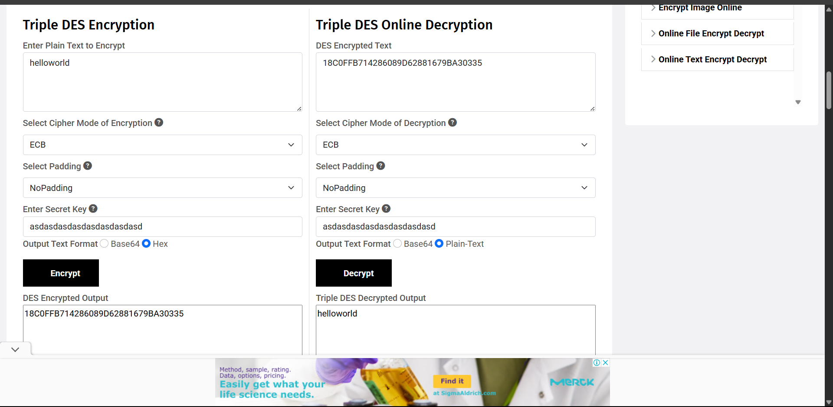

# AES:

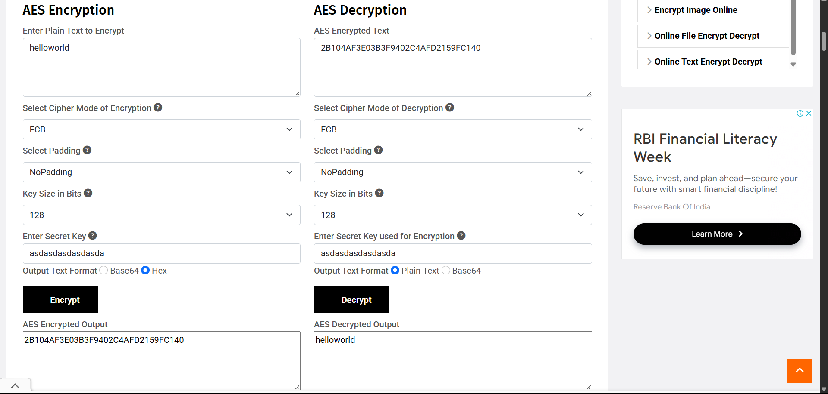

Above tool link: <https://www.devglan.com>

**Lab Practical #13:**

**Use of snort/Wireshark tool for network intrusion detection System to monitor network traffic and analyse attack patterns**

**Program:**

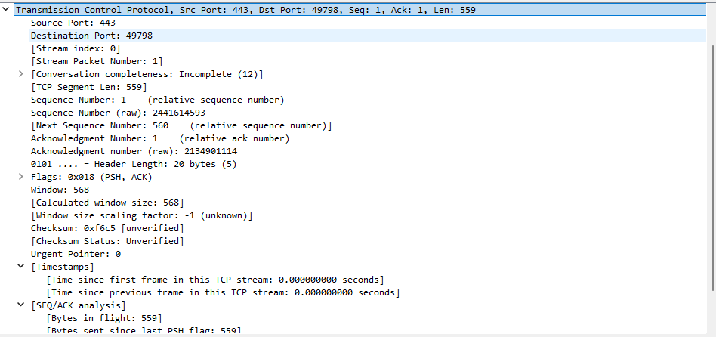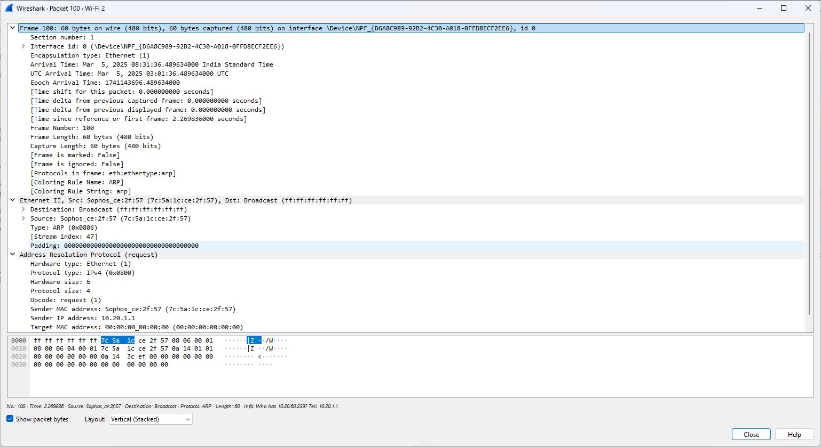

**http:**

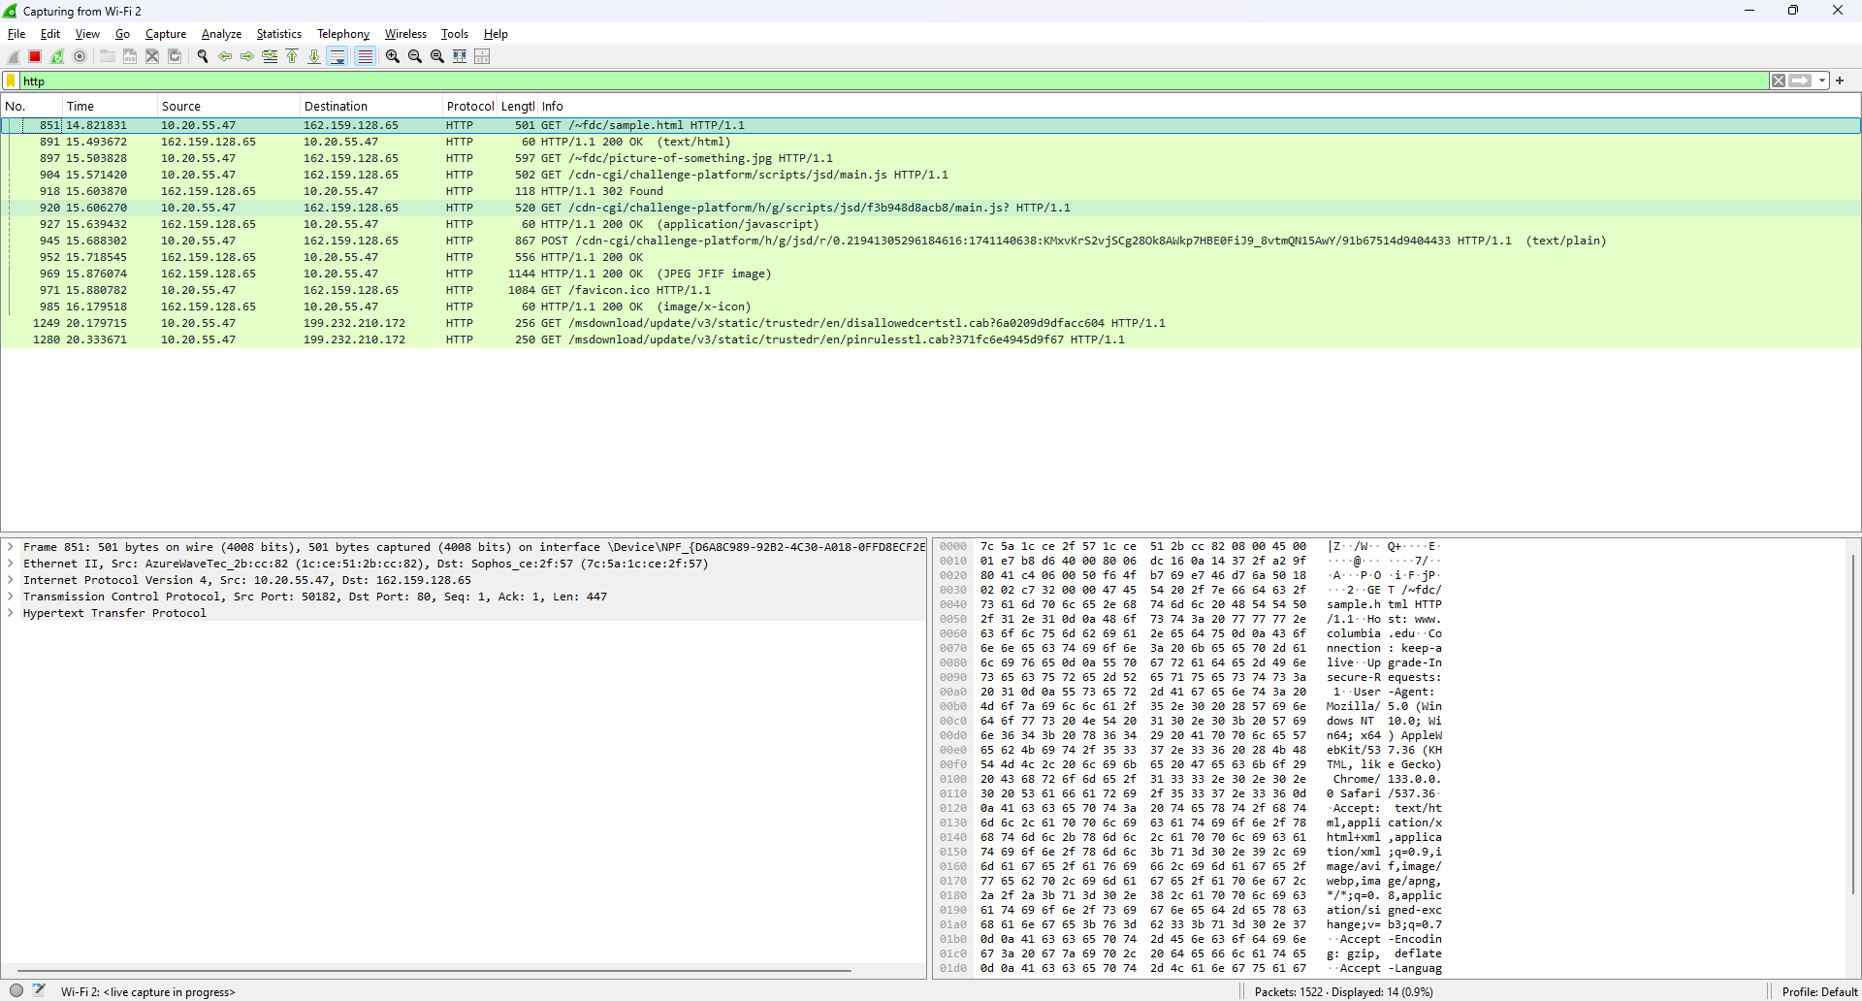

**Dns:**

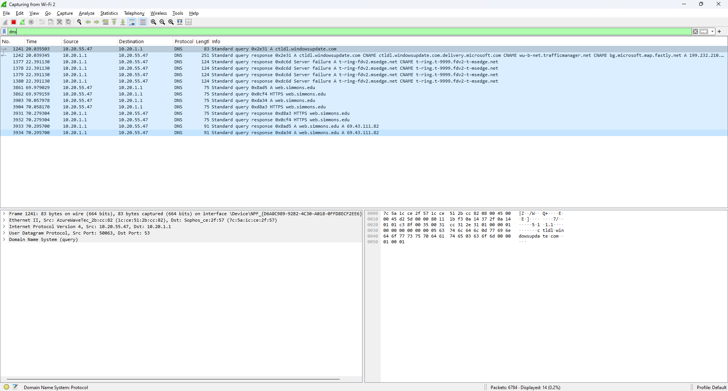

**Tcp:**

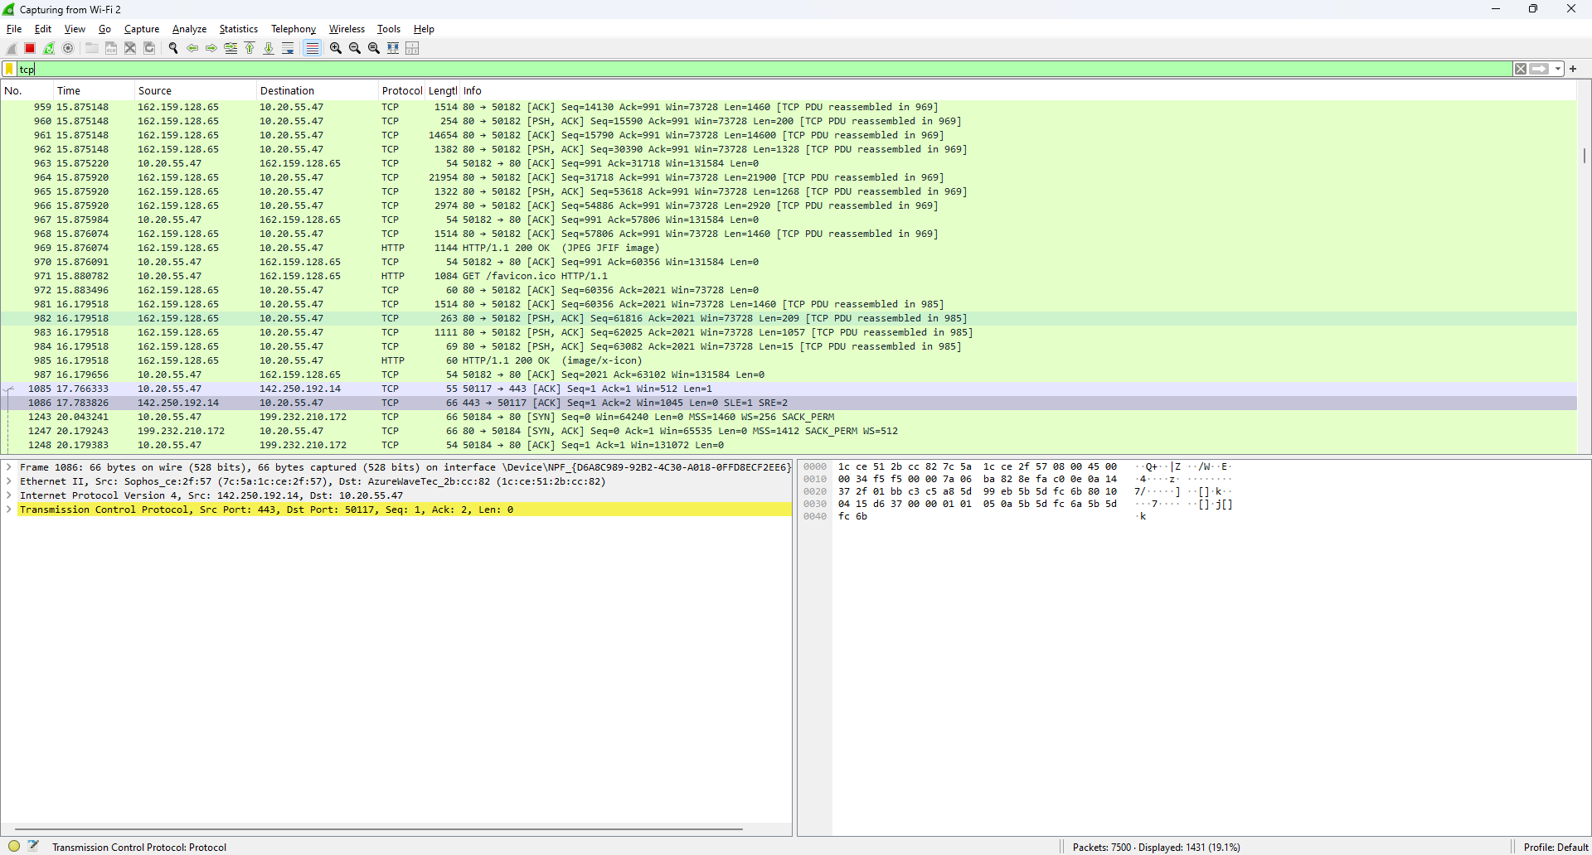

**Icmp:**

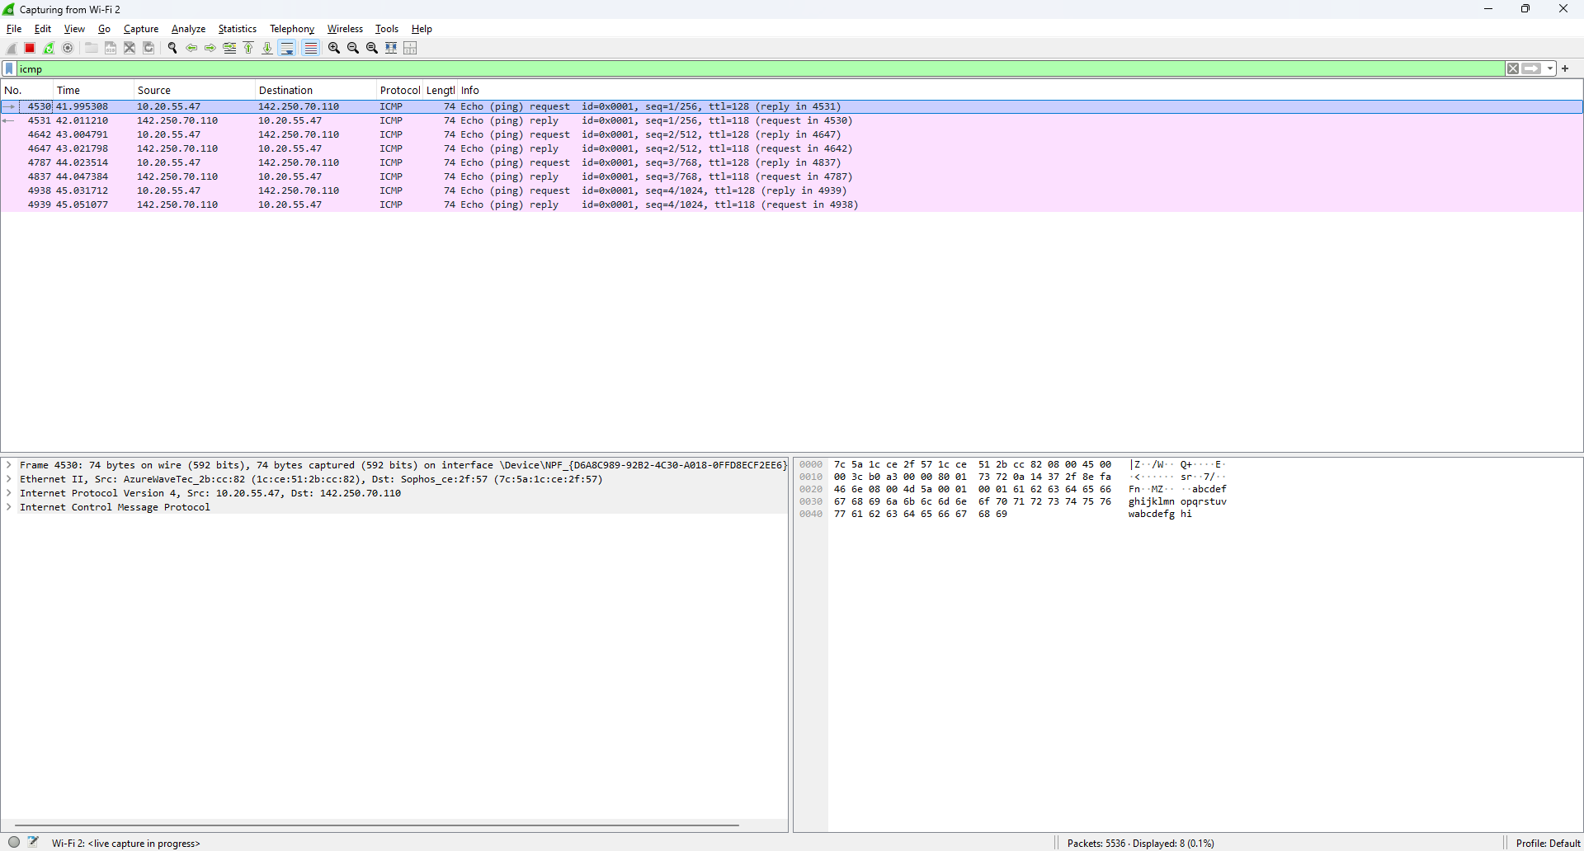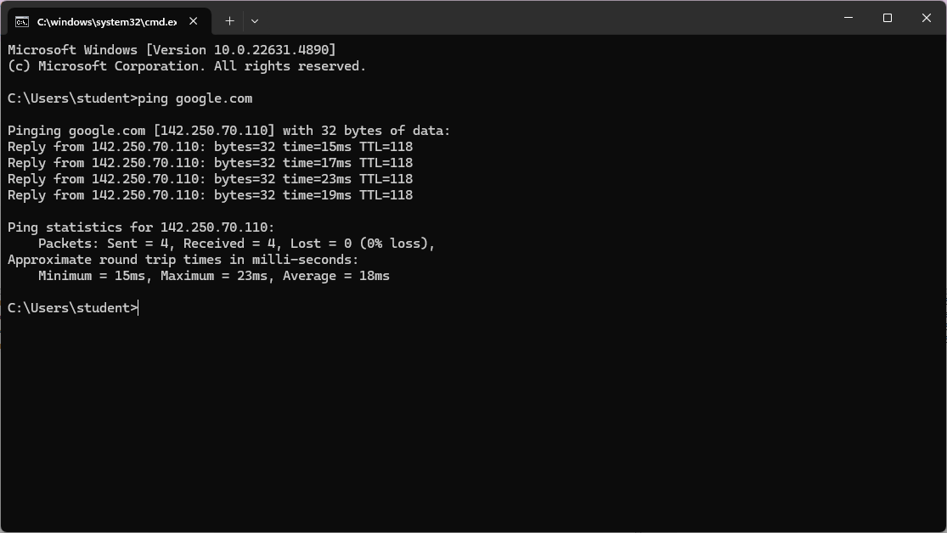

**Thank You**